# Project - Phase 3: Dashboard Implementation

Group Number 48

Sumasree Batttula

Mohan Karthik VijayaKumar

Sanjana Karthikeyan

Jananiya Sadasivam

Arizona State University

IFT 533 Topic: Data Visualization & Reporting for IT

Prof: Asmaa Elbadrawy

April 21, 2024

**Section I: Dashboard:**

**IPL DASHBOARD DESCRIPTION:**

The dashboard provides a comprehensive overview of IPL statistics from 2008 to 2024 through various visualizations. It includes bar charts showcasing team performances in terms of match wins, Player of the Match awards, and first innings scores. Additionally, a matrix illustrates the correlation between toss decisions and match outcomes. Another bar chart compares team performances when batting first versus chasing. A grid layout examines trends in win margins by runs and wickets over the years. Venue-wise distribution of Player of the Match awards is depicted using a horizontal bar chart. Performance trends over time are visualized for each team, highlighting improvements or declines. Clustered bar charts analyze team performance across match stages, while victory margins are compared through segmented bar charts. Finally, a line chart tracks the trend of runs scored over the years, offering insights into scoring patterns across IPL seasons. These visualizations utilize pre-attentive attributes such as color, length, and positioning to facilitate easy interpretation and comparison of data. Overall, the dashboard analysis enables stakeholders to understand historical patterns, identify trends, and make informed decisions regarding team strategies, player selections, and match tactics in the IPL. 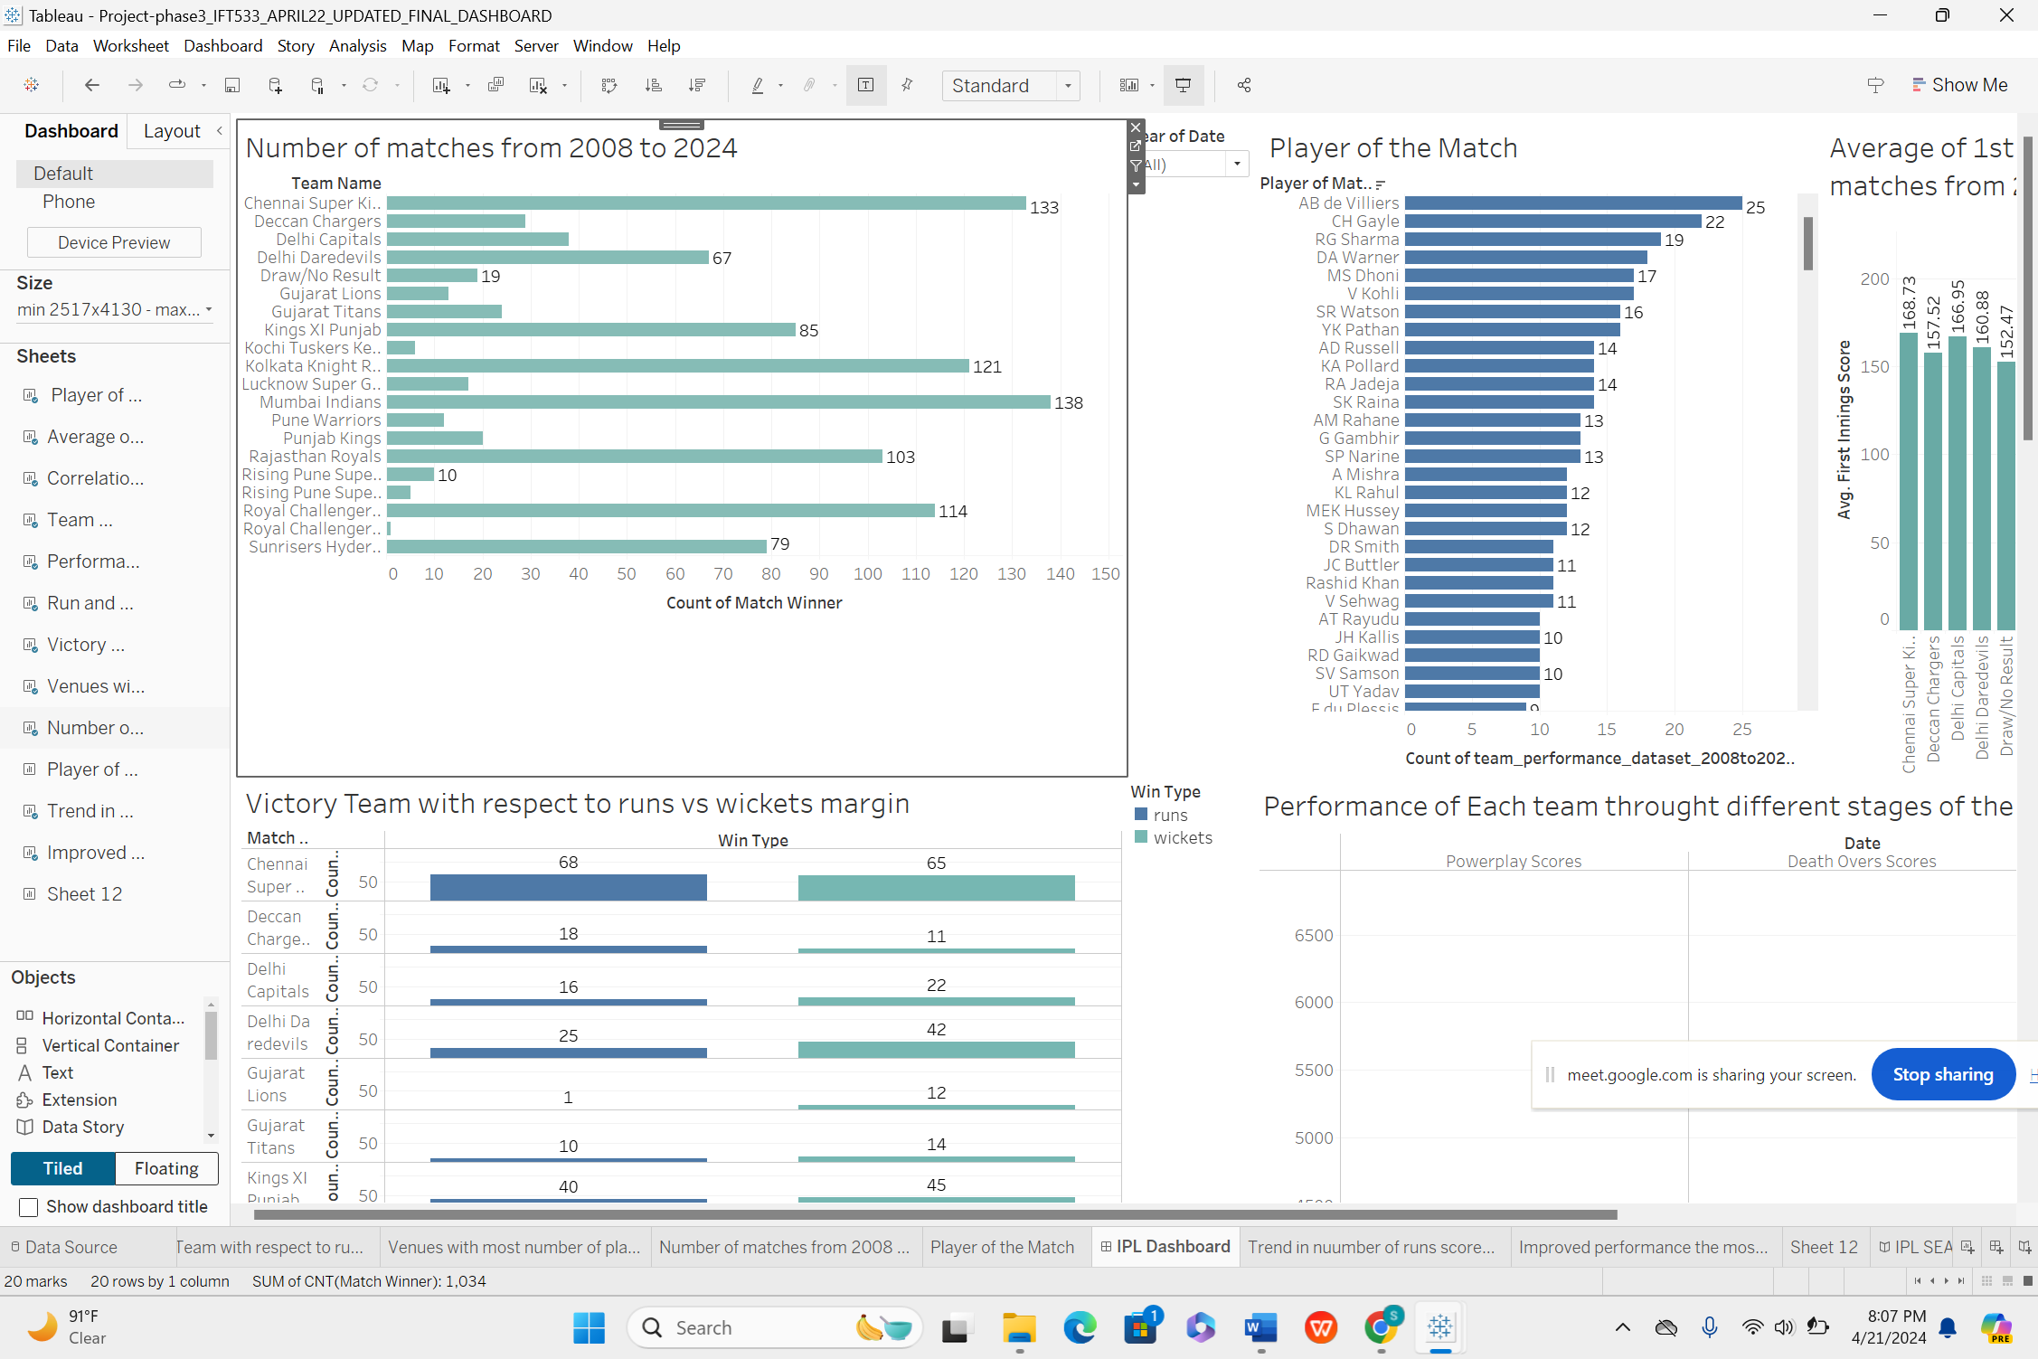

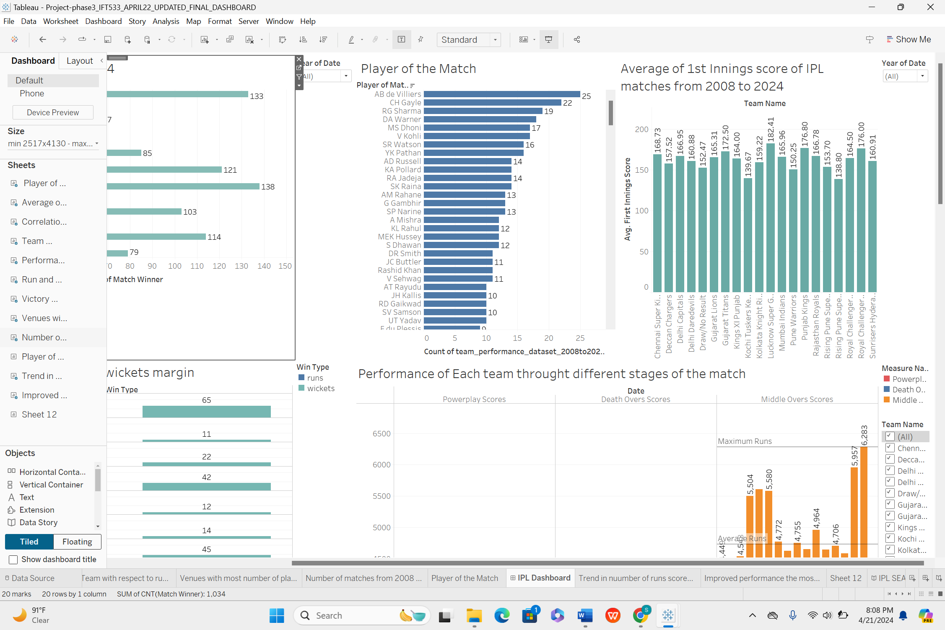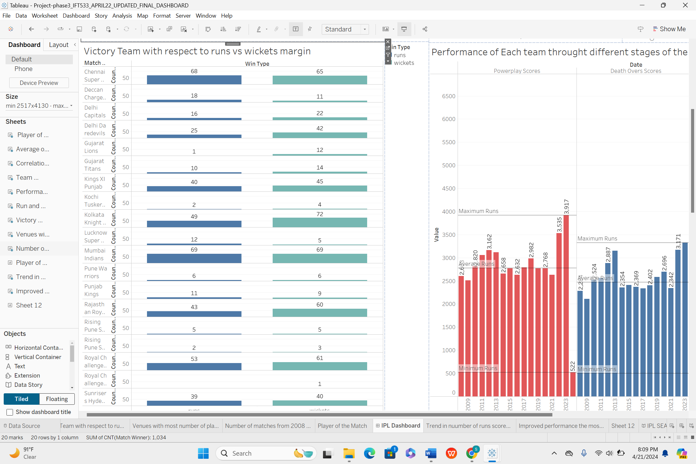

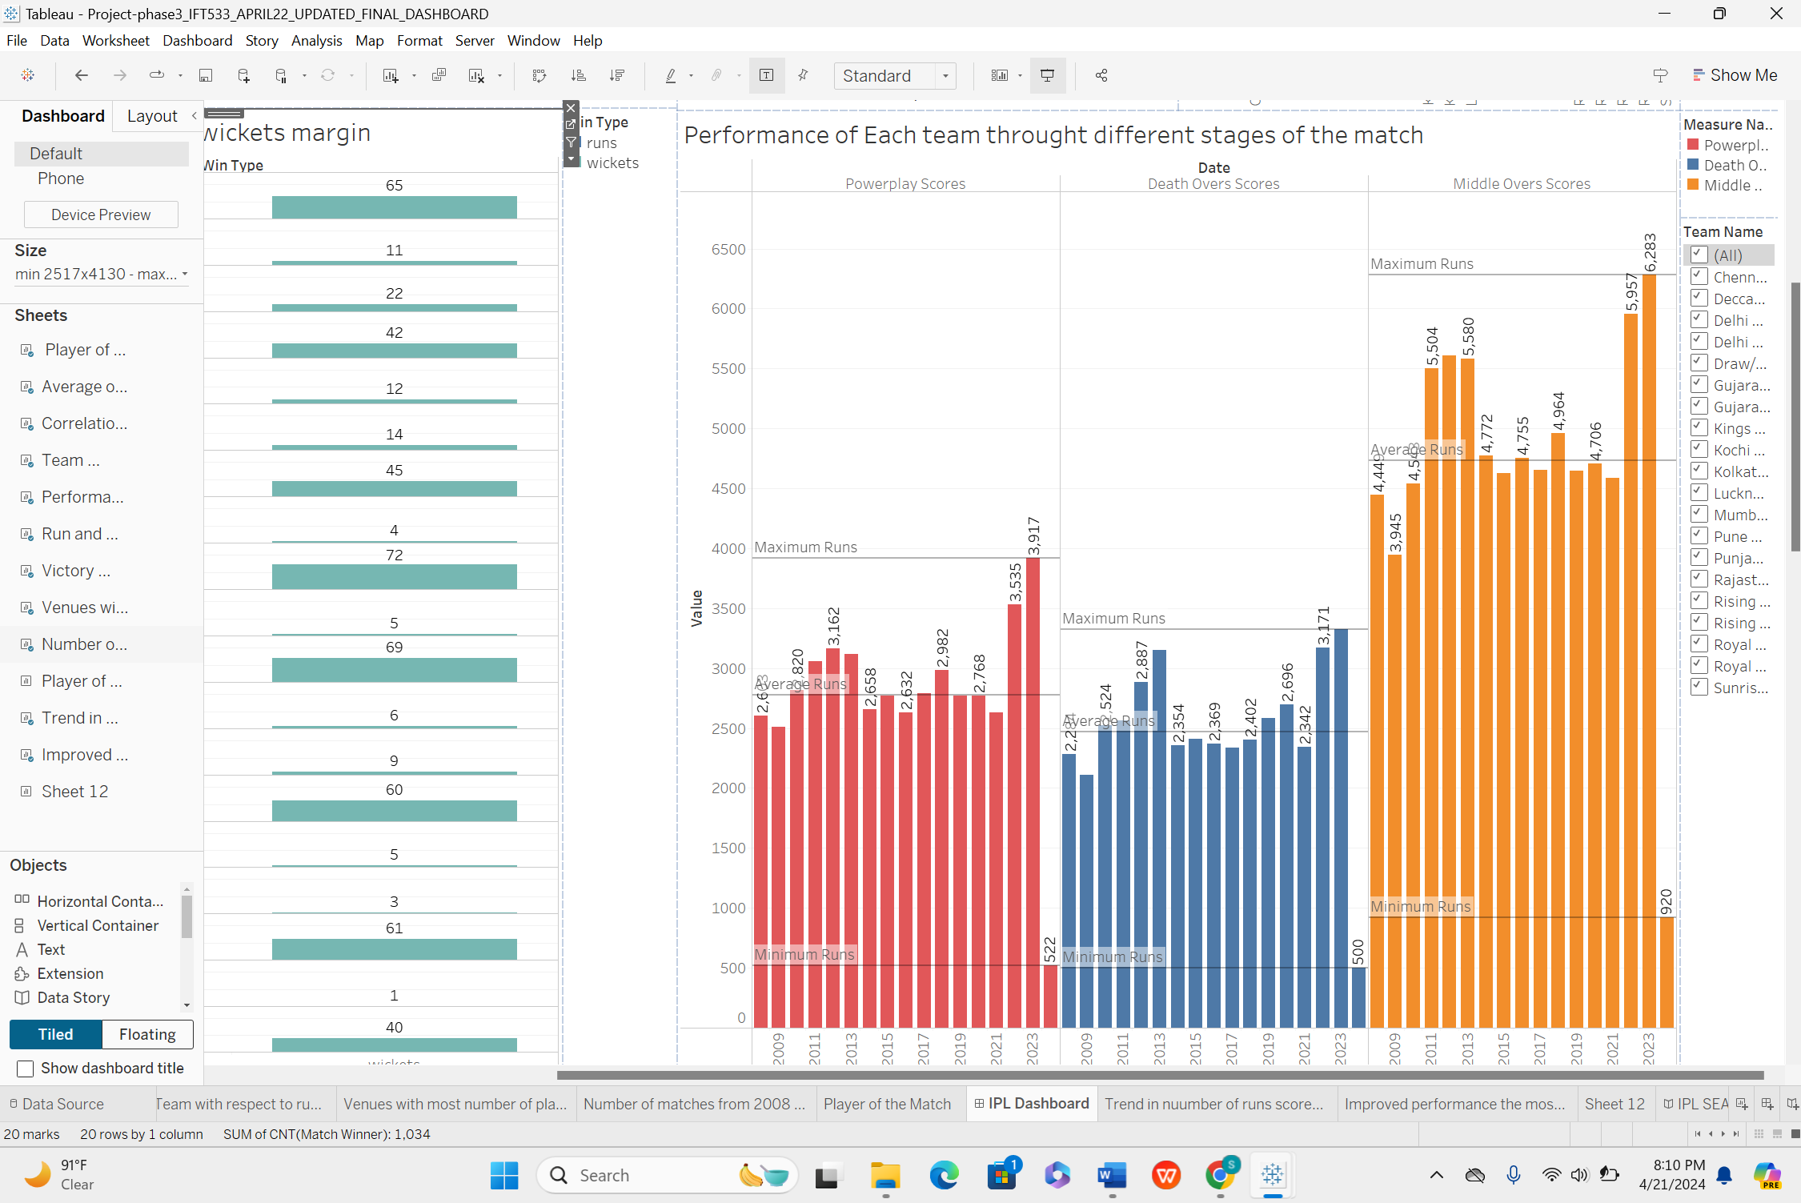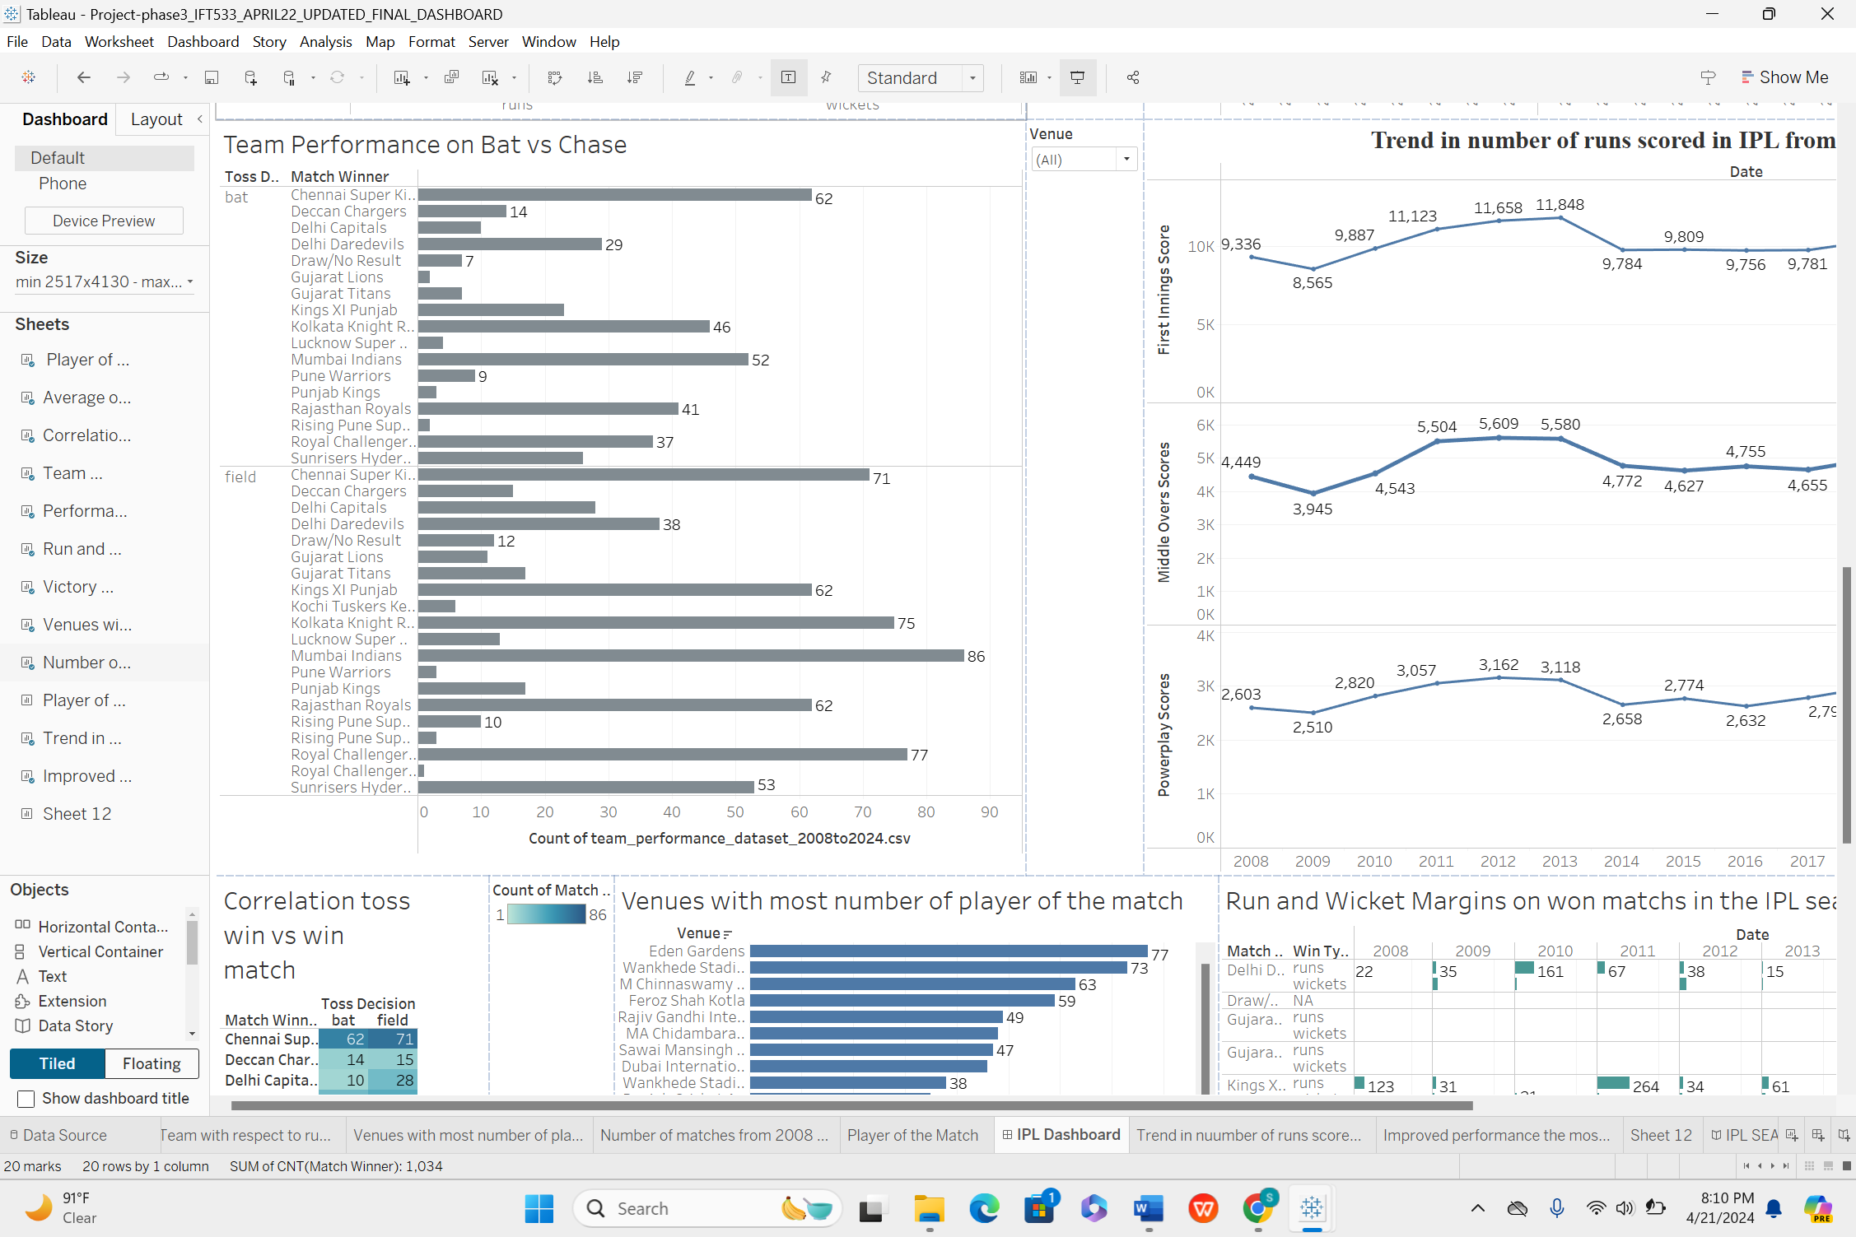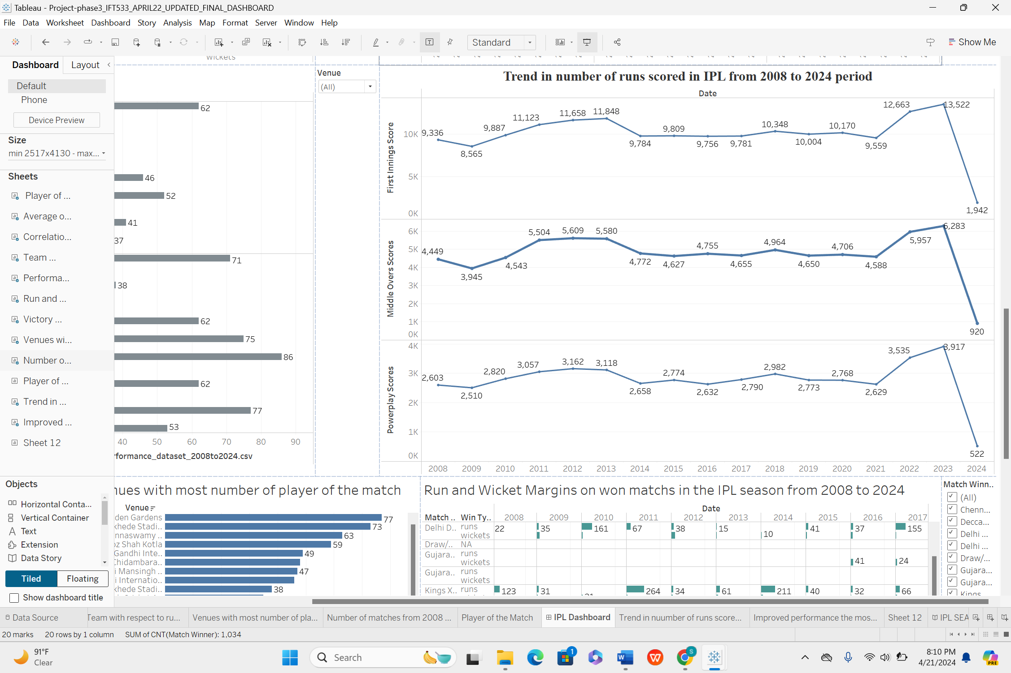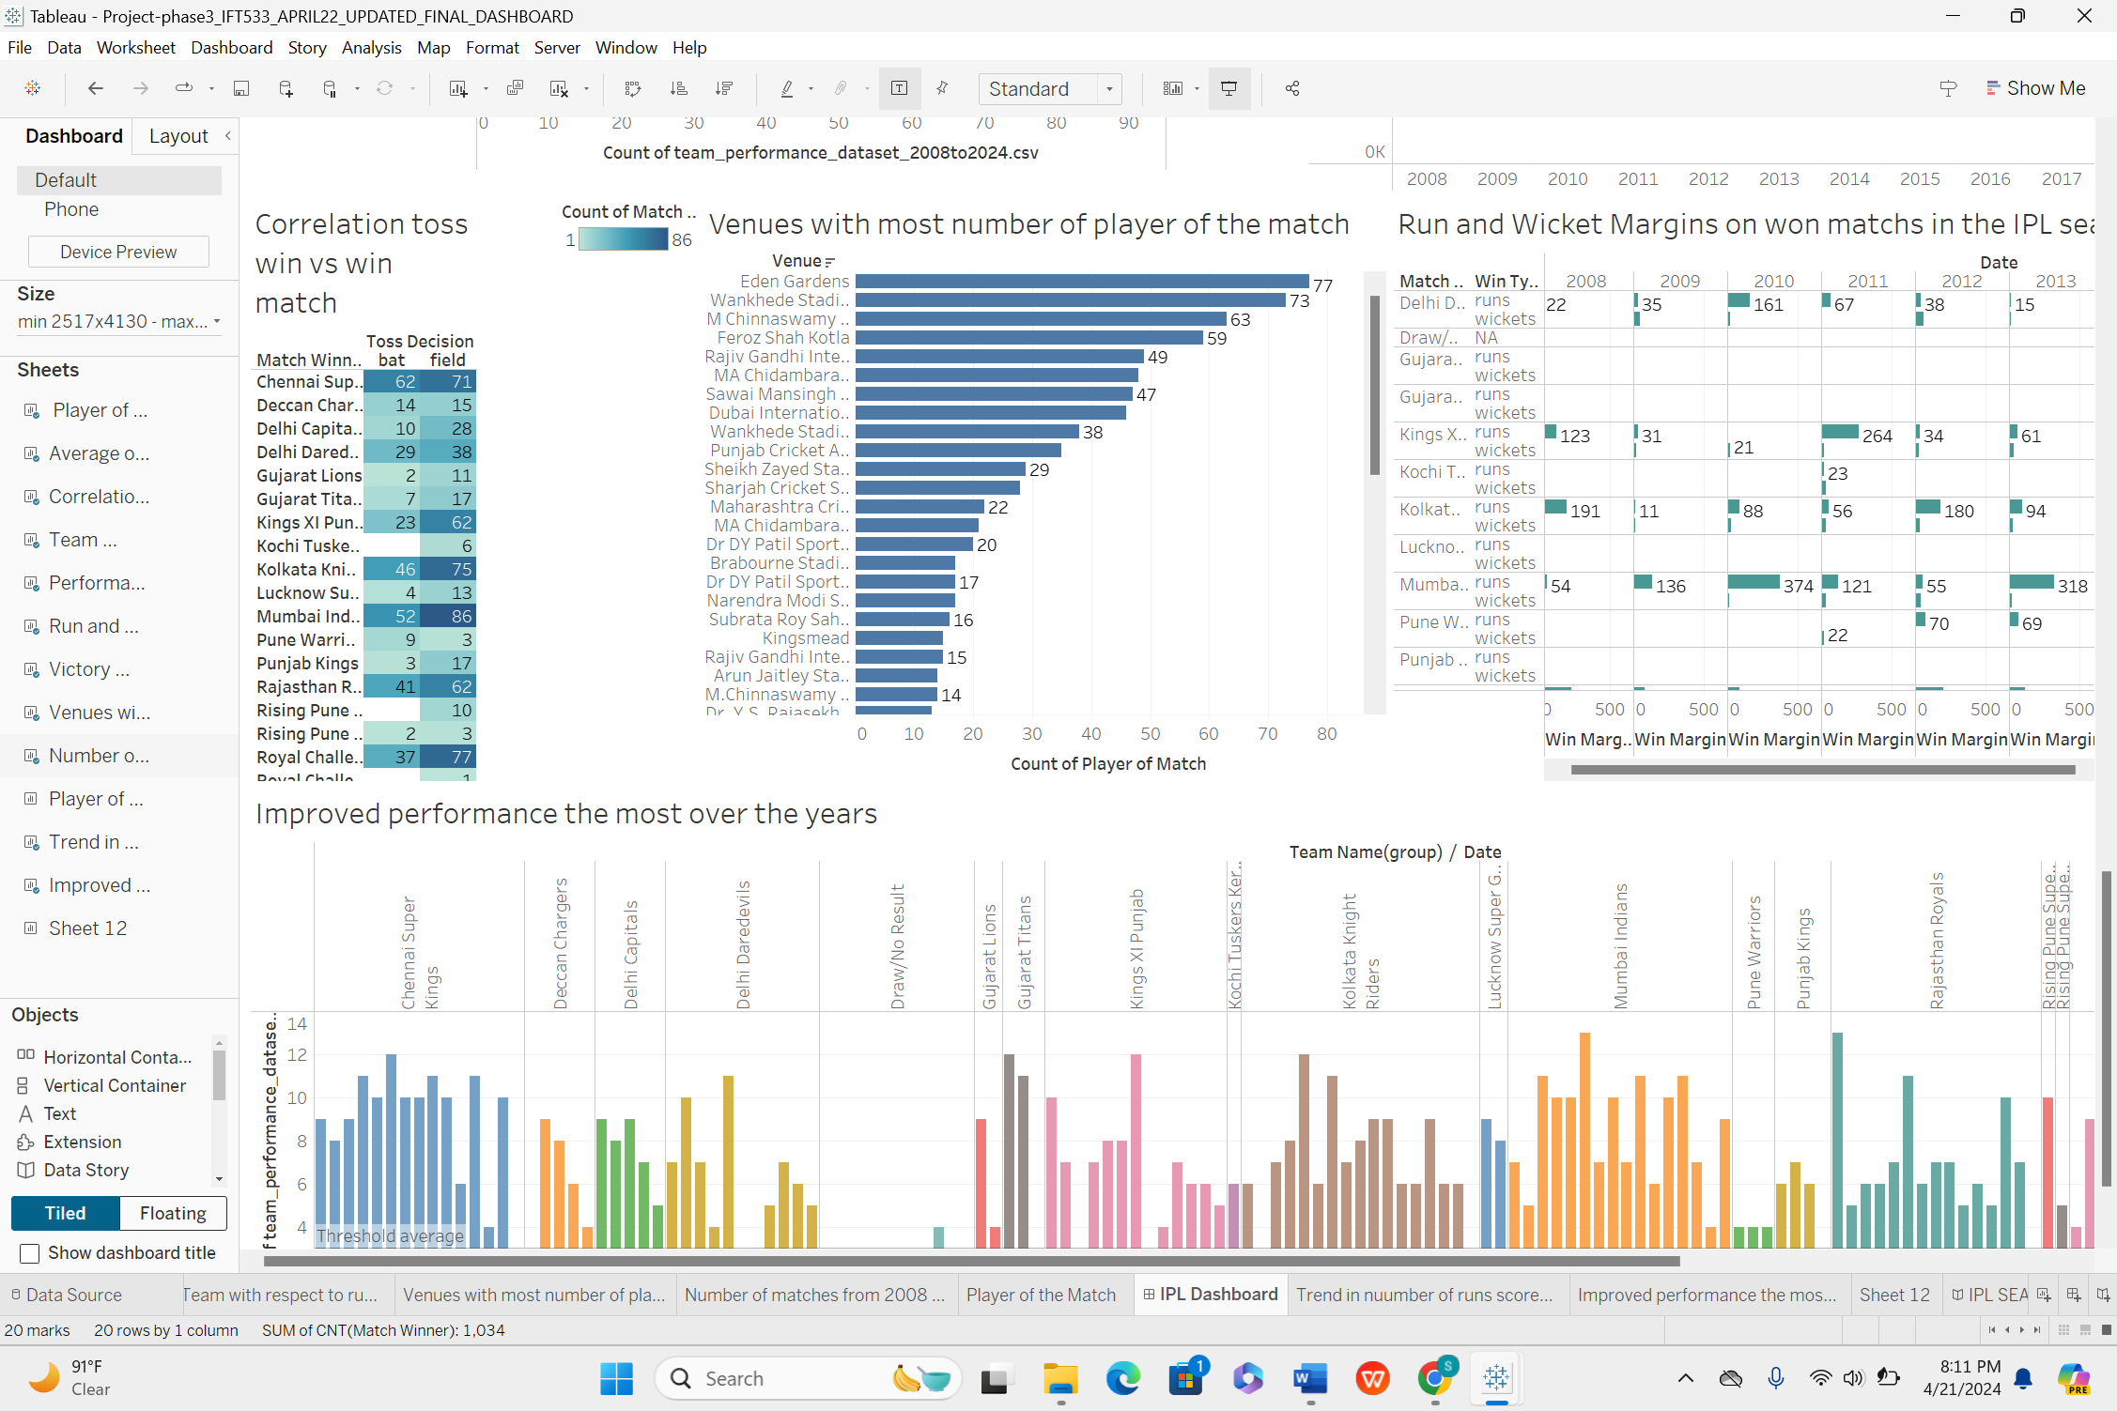

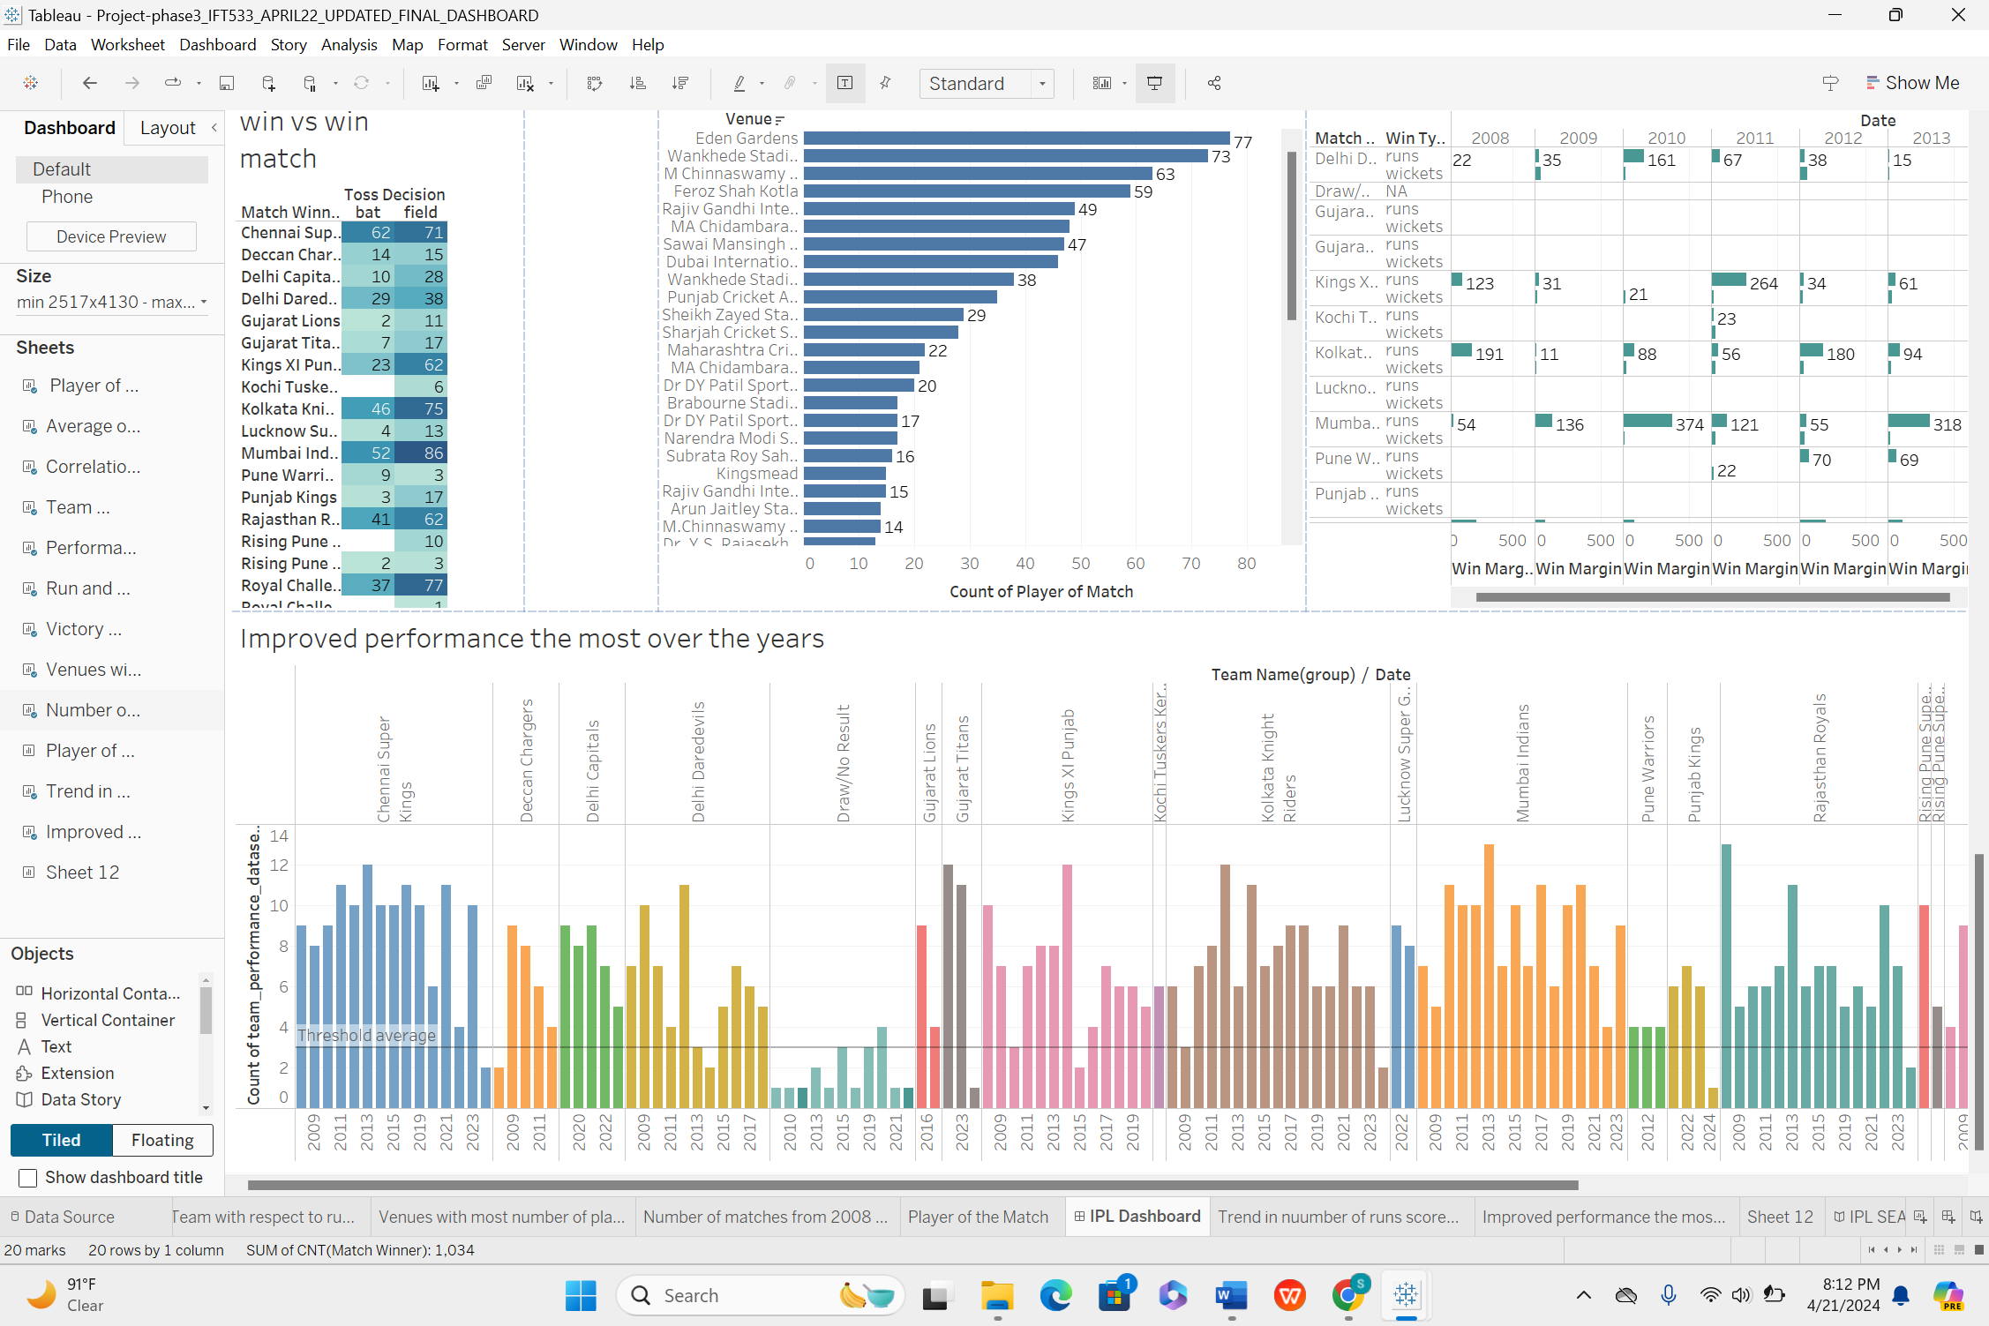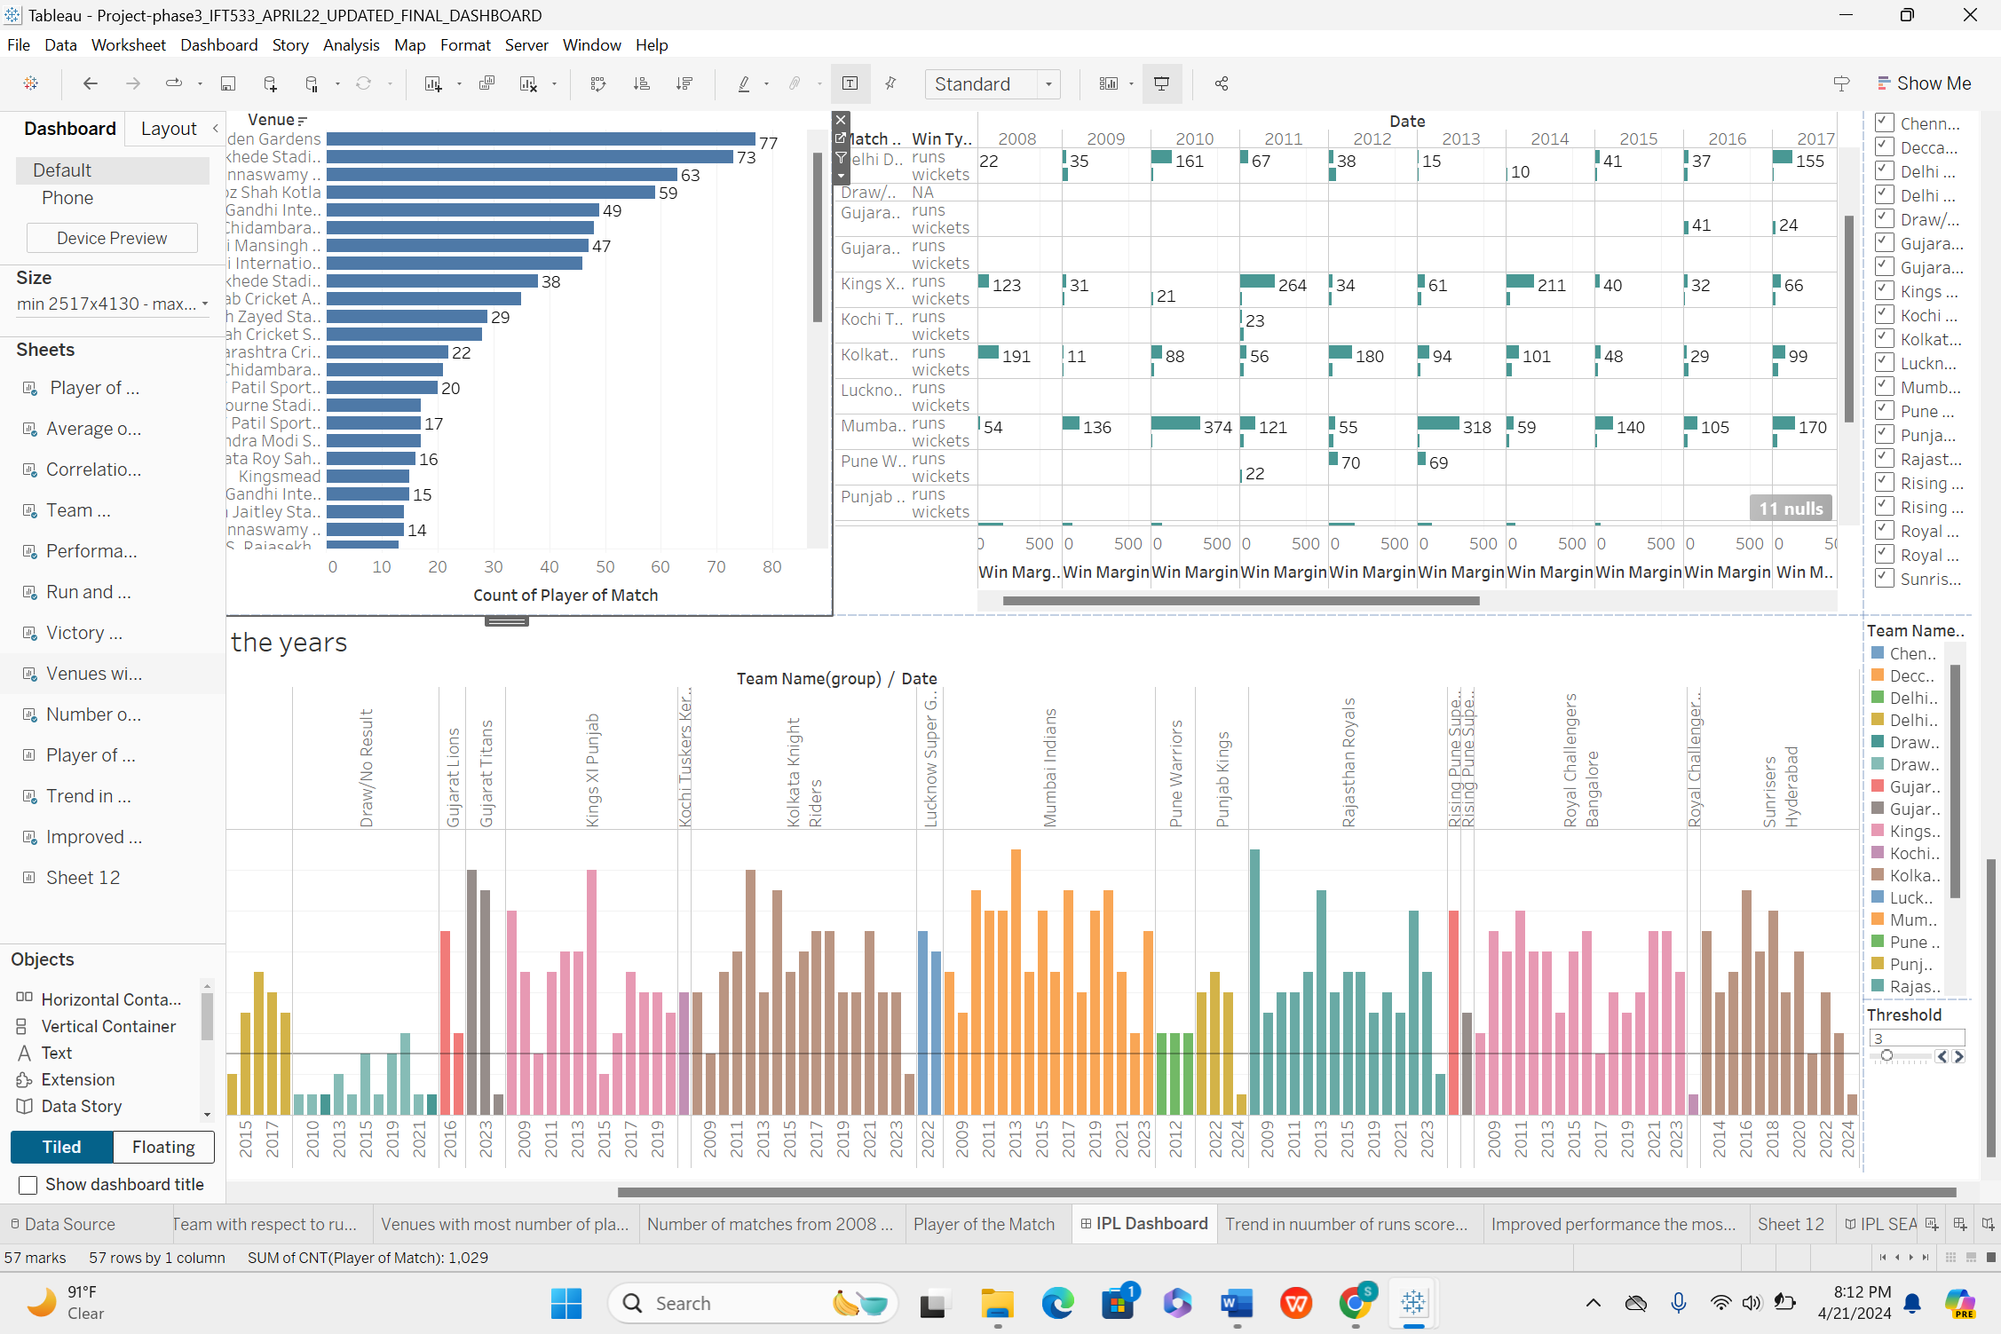

**Section II: Dataset**

These datasets provide extensive insights into the Indian Premier League (IPL), serving fans, sports analysts, and researchers alike. They encompass team performances, player details, IPL team specifics, and match performance data spanning from 2008 to 2024. The Team Performance Dataset monitors match results, strategies, and trends, while the Players Info Dataset delves into individual player profiles. Additionally, the IPL Teams Info Dataset furnishes crucial team particulars, and the IPL team performance Data delivers comprehensive match statistics. Updated on a weekly basis, these datasets aim to enrich analytical capabilities, with future iterations set to incorporate player statistics and image links for enhanced visualizations.

This dataset comprises 1034 rows and 18 columns.

**Attributes in Dataset:**

* Match ID: Unique code for each cricket match.
* Date: When the match was played.
* Teams: Names of the playing teams (e.g., Team A vs Team B).
* Venue: Location of the match.
* Toss Winner: Team winning the coin toss.
* Toss Decision: Bat or field first (choice by toss winner).
* Match Winner: Victorious team at the match end.
* Win Type: How the winner achieved victory (runs or wickets).
* Win Margin: Difference in score (runs or wickets) for the winner.
* 1st Innings Score: Total runs scored by the team batting first.
* 2nd Innings Score: Total runs scored by the team batting second.
* Player of the Match: Standout player in the match.
* Umpires: Officials overseeing the match.
* Powerplay Scores: Runs scored during the initial batting powerplay overs.
* Middle Overs Scores: Runs scored during the middle overs of the match.
* Death Overs Scores: Runs scored during the final death overs phase.

**Data preprocessing:**

Prior to delving into Tableau visualization, thorough preprocessing of the IPL team performance dataset is essential. This entails meticulously examining for any gaps, especially in key columns like 'Match ID', 'Teams', 'Toss Decision', 'Match Winner', and various score-related fields. Null values may be replaced with indicative placeholders like 'Unavailable', or incomplete records may be excluded, depending on the column's importance and the potential impact of the void.

For categorical variables such as 'Toss Decision' and 'Win Type', the most common occurrence—or mode—can be used as a substitute for missing entries. Conversely, numerical columns like 'Win Margin' and 'First Innings Score' may have their gaps filled with the column's average or median value, taking into account the data's skewness or symmetry.

Improvements in data readability, especially for dates, may involve converting numerical formats into more understandable date expressions using Tableau's date functionalities. Unique identifiers like 'Match ID' will be treated as nominal categories to prevent misinterpretation during analytical computations.

The final stage of preparation involves streamlining the dataset, which may include creating calculated metrics, pivoting for optimal data arrangement, or summarizing data at a higher level. These steps will ensure that the dataset is ready for generating insightful and accurate visualizations in Tableau.

**Section III: Potential Dashboard Users:**

* Media and Broadcasting Networks: These entities would use the dashboard to decide on broadcasting schedules, highlight packages, and to build narratives around players or teams for viewers.
* Match Officials and Referees: They could utilize the data to prepare for games, studying team behaviours for better in-match decision-making and performance reviews.
* League Organizers and Franchise Owners: To strategize on team compositions, match logistics, and promotional activities based on historical data and current trends.
* Fitness and Medical Staff: By analysing player statistics, they could monitor players' physical performances and develop personalized training and recovery programs.
* Investors and Financial Analysts: For those looking at the financial aspect of sports teams, including their valuation and the potential return on investment.
* Policy Makers and Sports Regulators: To ensure compliance with regulations, promote fairness, and use data for policy decisions that could impact the league.
* Player Associations and Unions: To protect players’ interests and negotiate collective bargaining agreements based on performance data.
* Sports Psychologists and Performance Coaches: To use data for developing mental strategies and improving players' on-field performances.
* Social Media and Digital Marketing Teams: To create targeted content that engages fans on digital platforms, leveraging insights into player popularity and match highlights.
* Advertisers and Sponsors: Companies interested in sponsoring teams or matches can identify the most impactful associations based on team performance and popularity.
* International Cricket Council (ICC): For insights into the performance of national players participating in the league, which can influence international match preparations and strategies.

**Section IV: List of Questions**

1) Which team has won the most matches in the IPL from 2008 to 2024?

2) Who are the top players based on the Player of the Match awards?

3) What is the average first innings score across all IPL matches in the dataset?

4) Is there a correlation between toss decisions and winning matches?

5) How do teams perform when they bat first vs. when they chase?

6) What is the trend of run margins and wicket margins in won matches over the years?

7) Which venues host the most player of the match awards?

8) Which teams have improved their performance the most over the years?

9) How does the performance of a team vary throughout different stages of the match (powerplay, middle overs, death overs)?

10) Are victories more often by runs or wickets?

11) Is there a trend in the number of runs scored in the IPL over the years?

**Section V: Dashboard Plots**



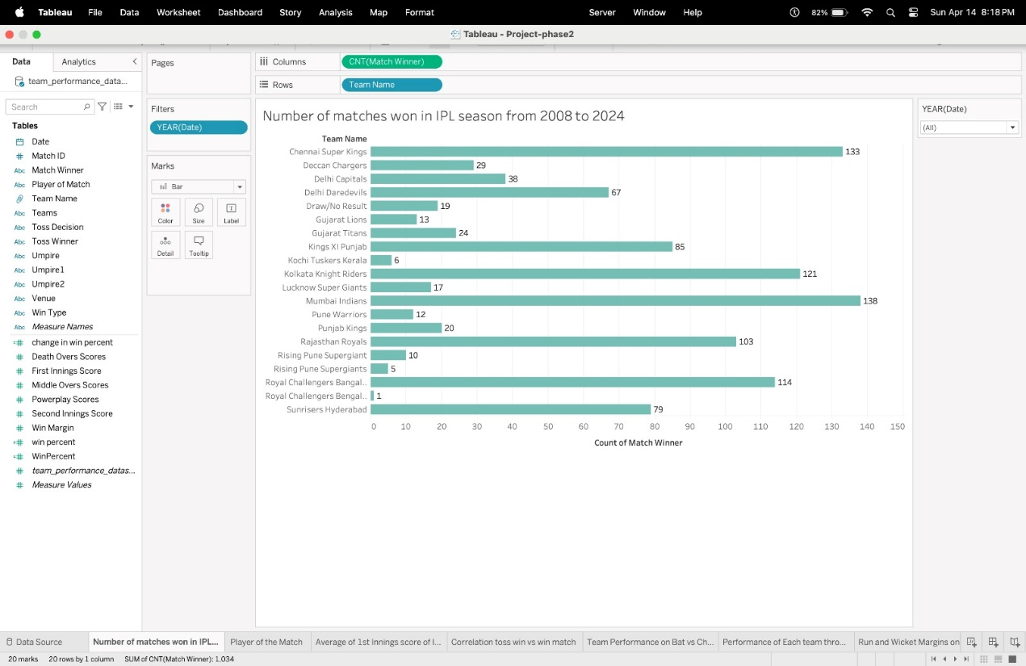

The visualization presents the number of matches won by each IPL team from 2008 to 2024 depicting the varying lengths of horizontal bars highlight team dominance, with a consistent teal-green color scheme aiding quick comparison.

Pre-attentive attributes like length and color ensure clear visual comparison across teams.



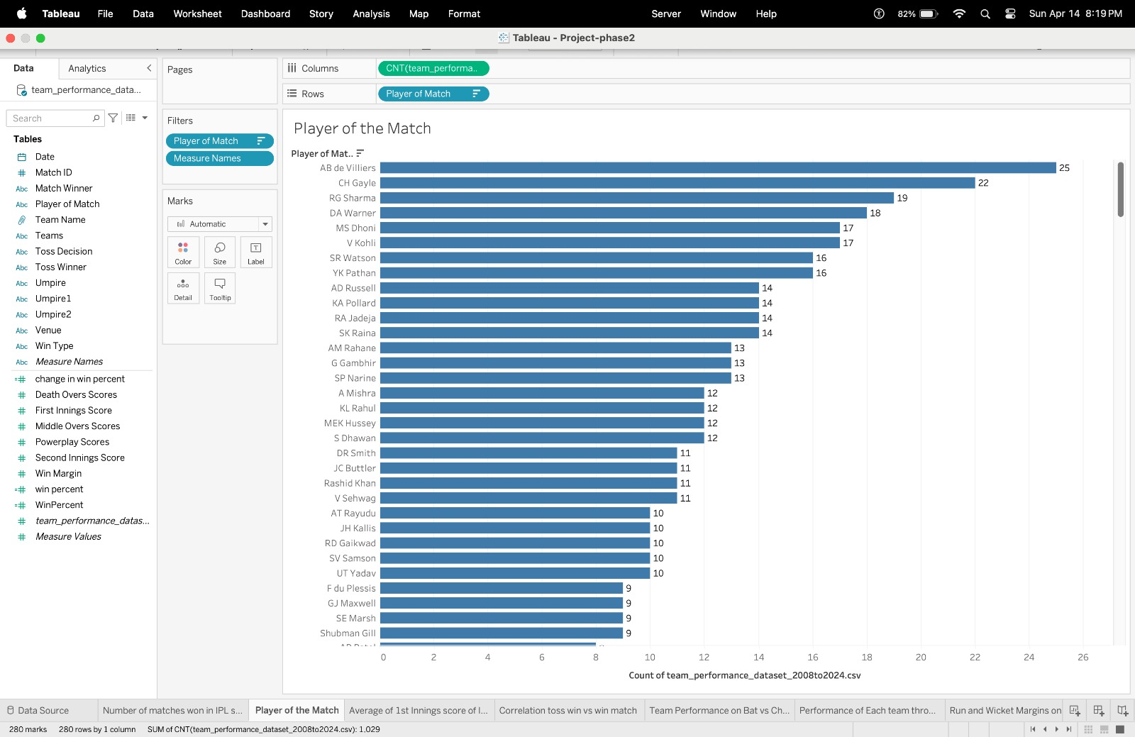

This horizontal bar chart displays 'Player of the Match' awards received by IPL players from 2008 to 2024. The length of each bar represents award frequency, with top players positioned at the chart's top. Bars are uniformly colored in blue, emphasizing bar length for comparison. Horizontal orientation aids player name readability

Pre-attentive attribute used for this visualization is length that ,orientation.



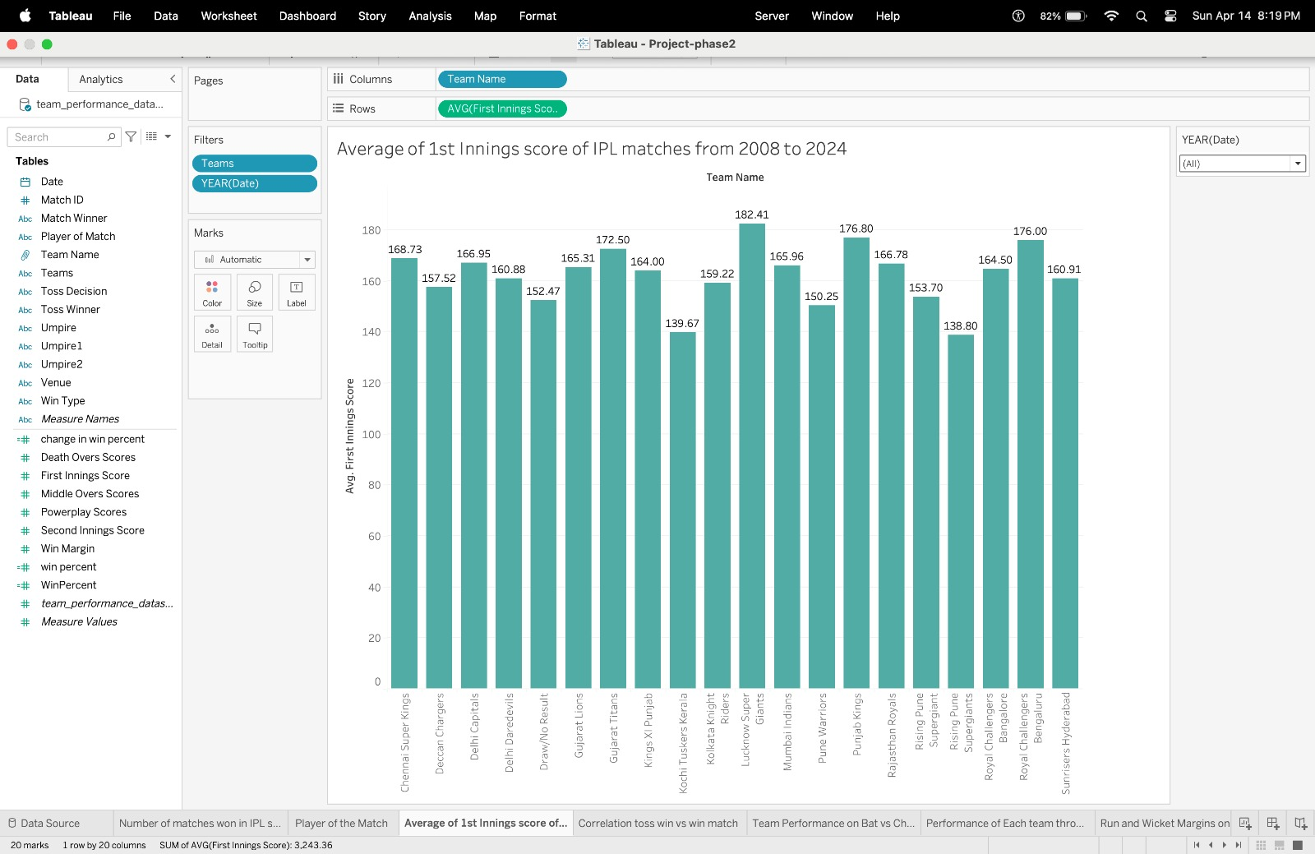

This vertical bar chart illustrates IPL team average first innings scores from 2008 to 2024. Each bar denotes a team, labeled along the x-axis, with bar height reflecting their average score, indicated on the y-axis. A year filter is available for data refinement. Bars are uniformly shaded in teal, with numerical labels atop each bar for clarity.

Pre-attentive attribute for this visualization are height of bar, numeric labels,



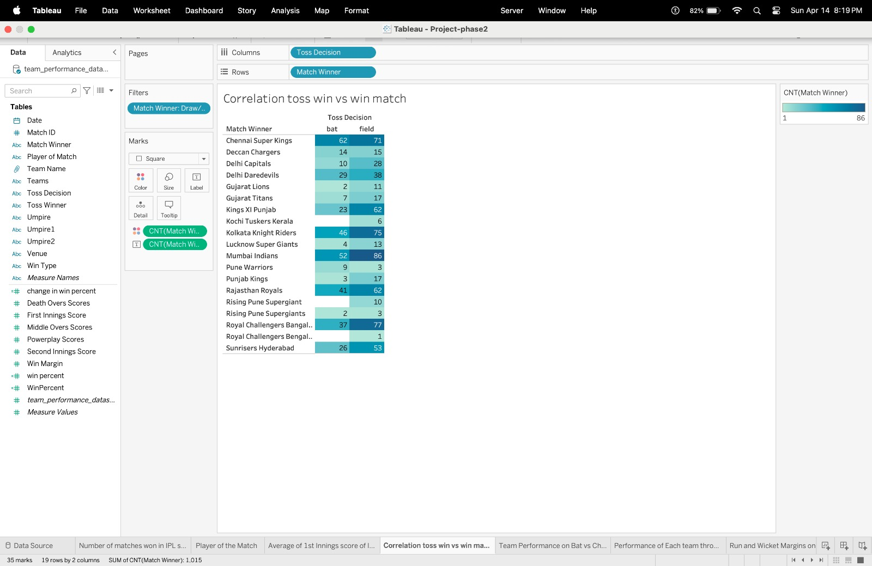

The visualization presents a matrix correlating IPL teams with their toss decisions and subsequent match wins. Teams are listed vertically, while the horizontal axis denotes the toss decision—bat or field. Each cell quantifies the number of wins a team achieved post-toss decision, offering insights into the impact of these decisions on match outcomes. Clear numerical labels accompany each cell for precise win counts.

Pre-attentive attribute used for above visualisation are size, color saturation, direct labels.



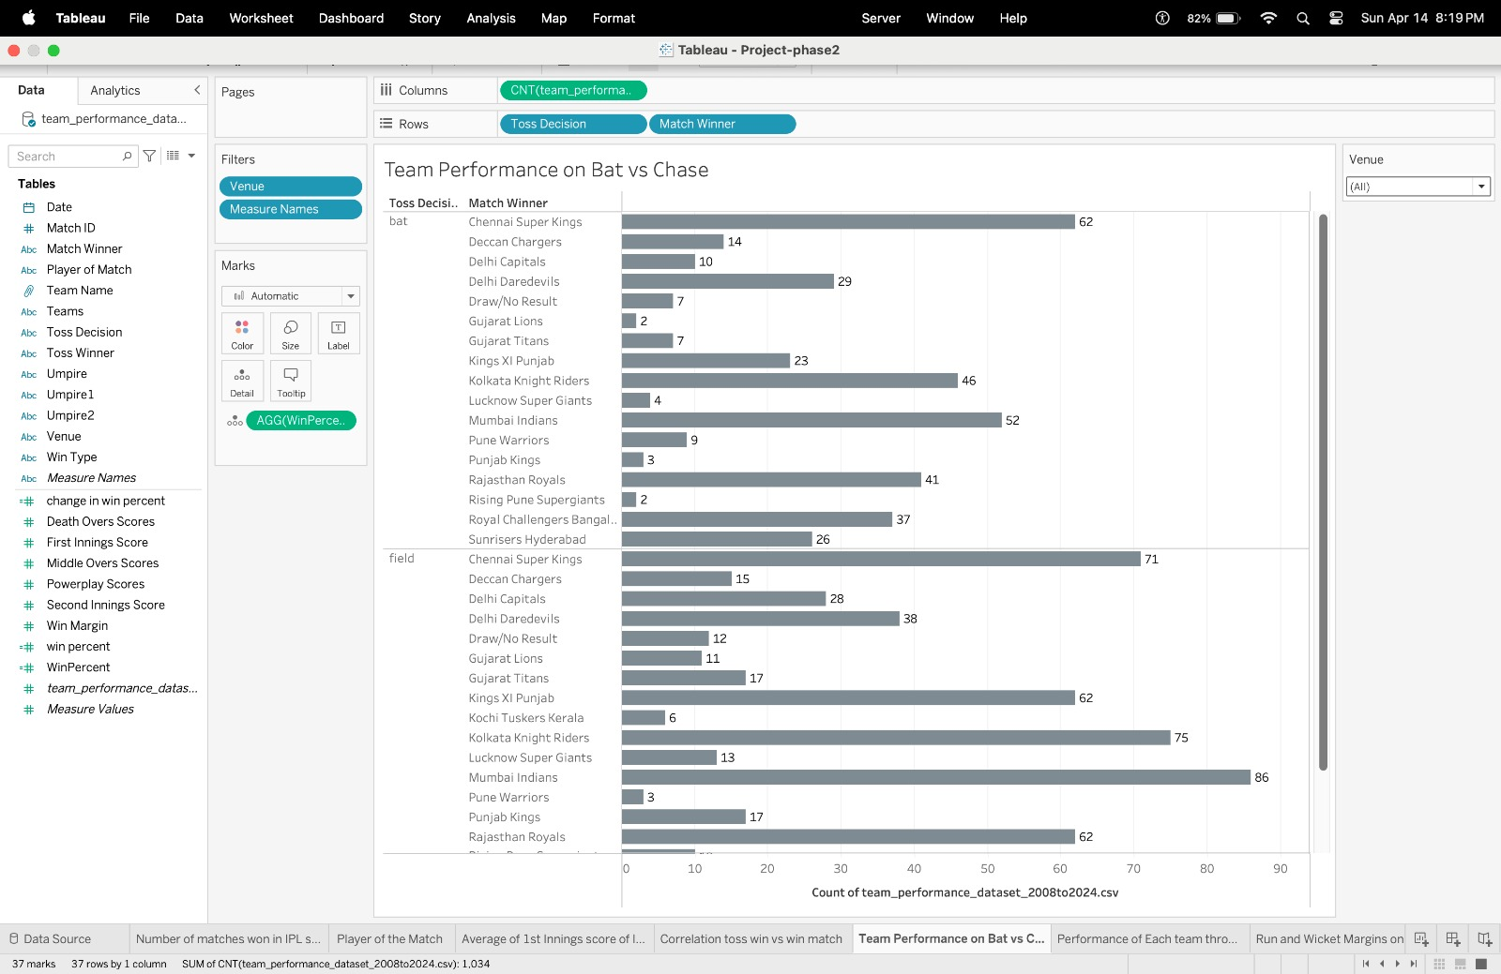

The chart compares team performance based on batting first or chasing. Each team has two bars representing wins when batting first and when chasing. Bar length indicates wins in each scenario. Different shades distinguish between batting conditions. Aligned bars facilitate comparison, while numerical labels offer precise win counts for each condition.

Pre-attentive attribute used for above visualisation are length, color, direct labels.



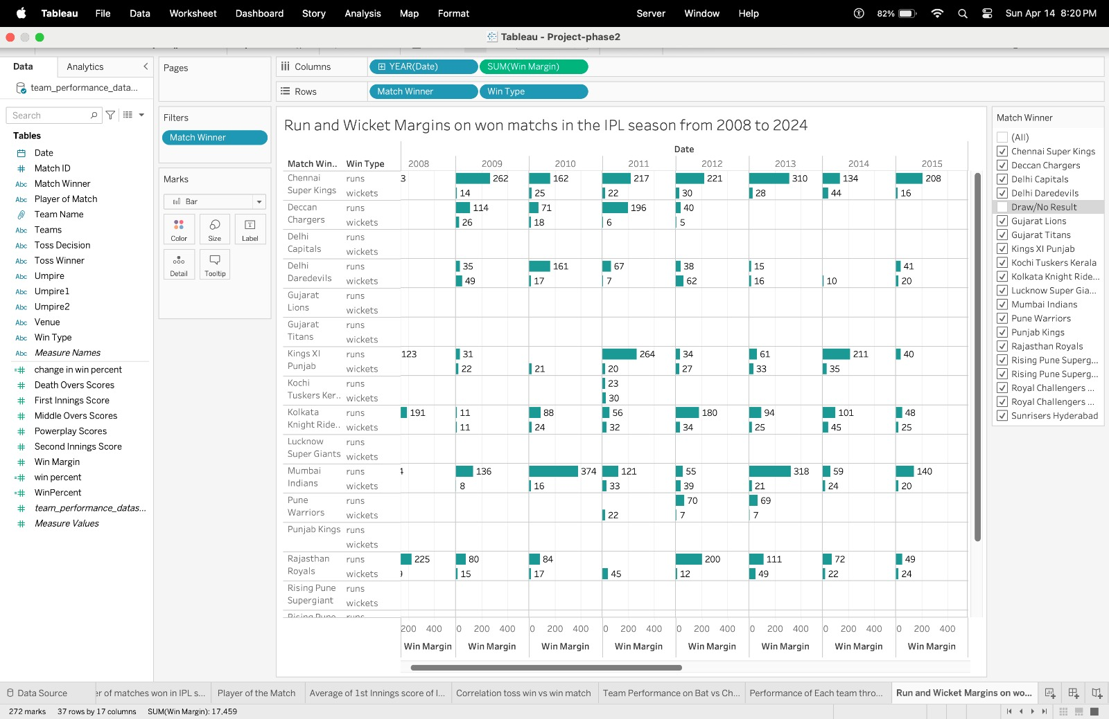

The visualization exhibits a grid illustrating IPL match win margins categorized by runs and wickets across teams and years. Each cell denotes the margin of victory for a team in a particular year, differentiated by win type. This aids in identifying patterns in teams' winning methods over time—whether they primarily win by runs or wickets.

Pre-attentive Attributes and Colors:

* Numerical Values: They offer precise win margins for quick quantitative assessment.

* Grid Layout: Organized positioning allows for straightforward horizontal (yearly) and vertical (by team) comparisons.

* Color Shading: Distinguishing colors or shades for 'runs' and 'wickets' enables easy identification of win types.



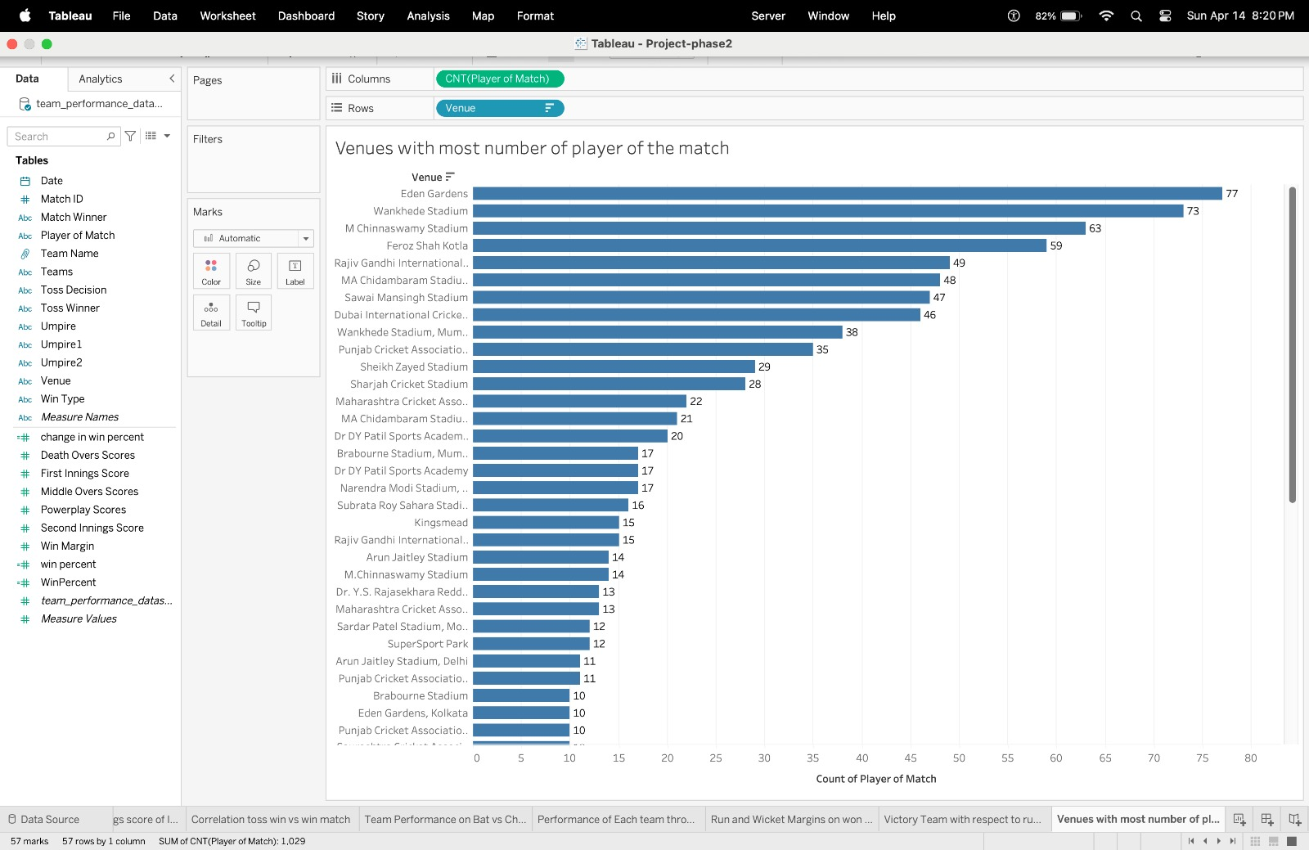

The horizontal bar chart depicts the distribution of 'Player of the Match' awards across various IPL venues. Each bar represents a venue, with its length indicating the total number of awards bestowed there. Ordering the venues by award count facilitates quick identification of the most frequently awarded locations. Pre-attentive attributes include bar length, alignment along a common baseline, and color consistency or categorization for different venue types



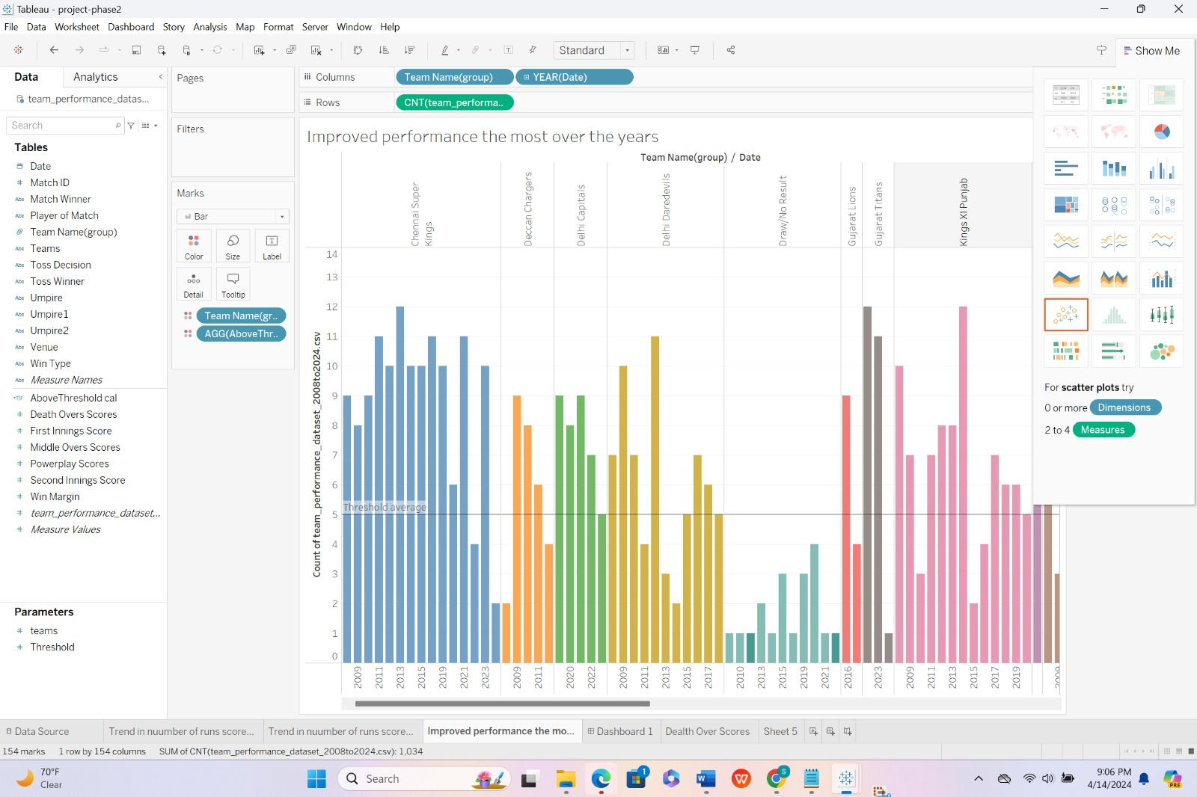

The bar chart visualizes the yearly performance of IPL teams based on specific metrics. Each bar represents a team's performance in a given season, with color-coded bars indicating different teams. Trends, such as improvement or decline, can be easily observed by examining the trajectory of the bars over time.

Key pre-attentive attributes include bar height for comparison, color coding for team differentiation, and the horizontal arrangement for temporal perception

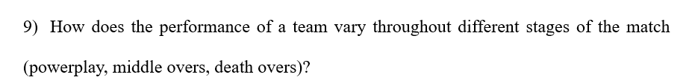

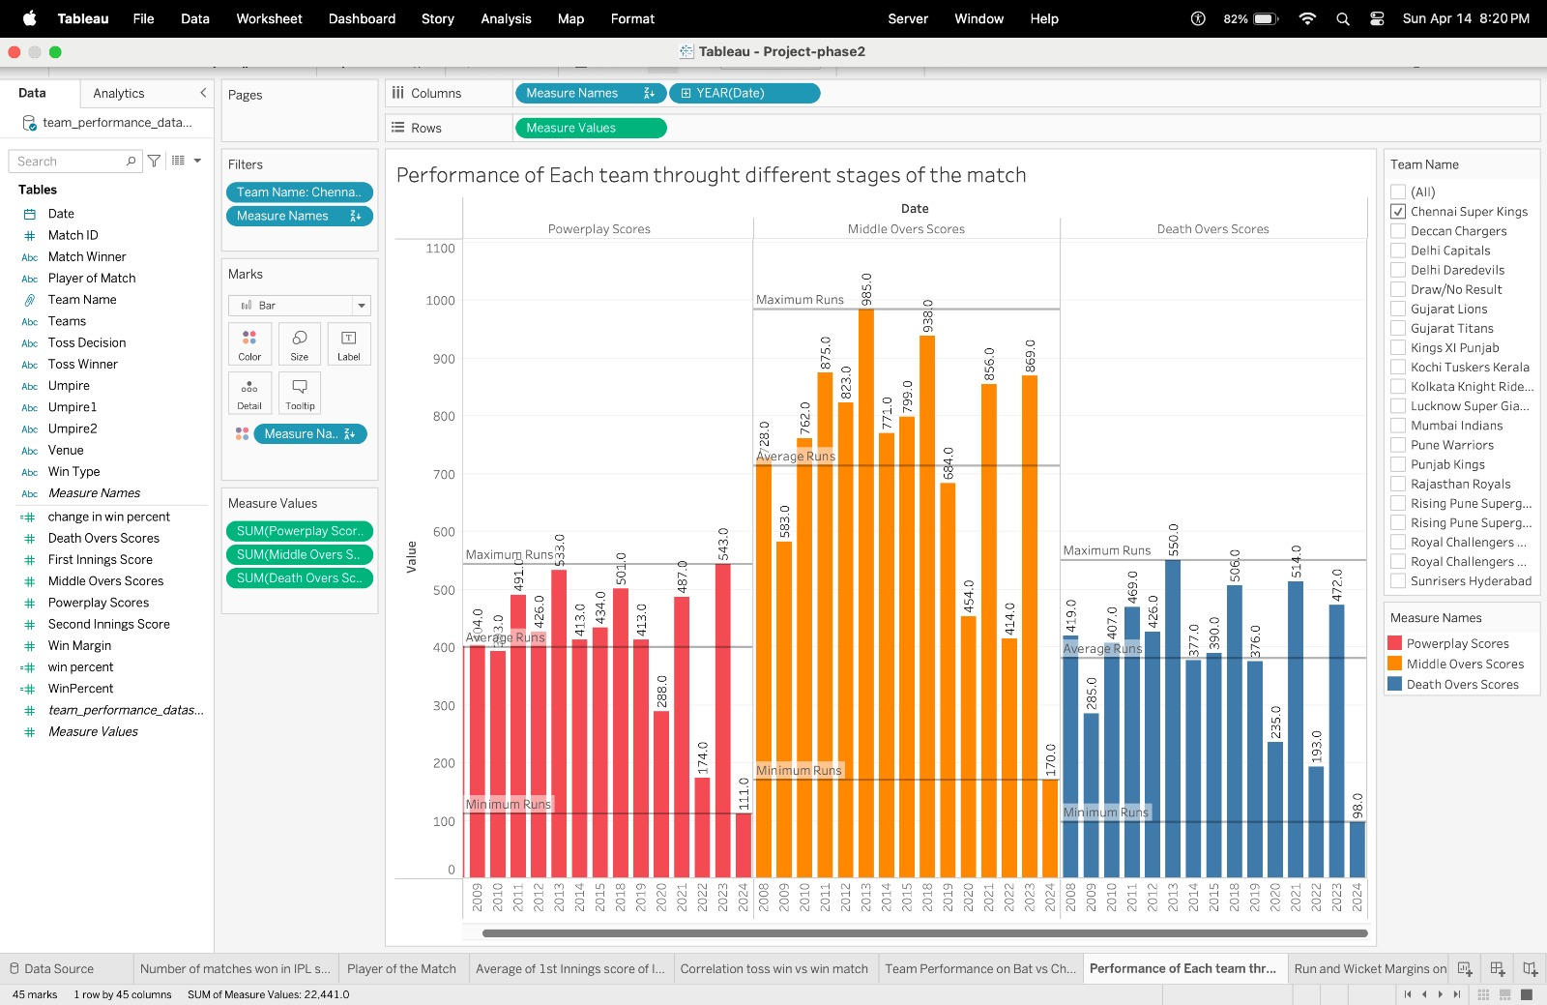

The visualization employs a clustered bar chart to analyze IPL team performance across match stages: Powerplay, Middle, and Death overs. Each group of bars, distinguished by color, corresponds to a stage, with individual bars representing team performance in terms of runs scored. This design facilitates easy comparison of scoring strategies, aided by color-coding for stage differentiation

Pre-attentive attributes used for the above visualisation are length, spacing and grouping, color, interactive control lines.



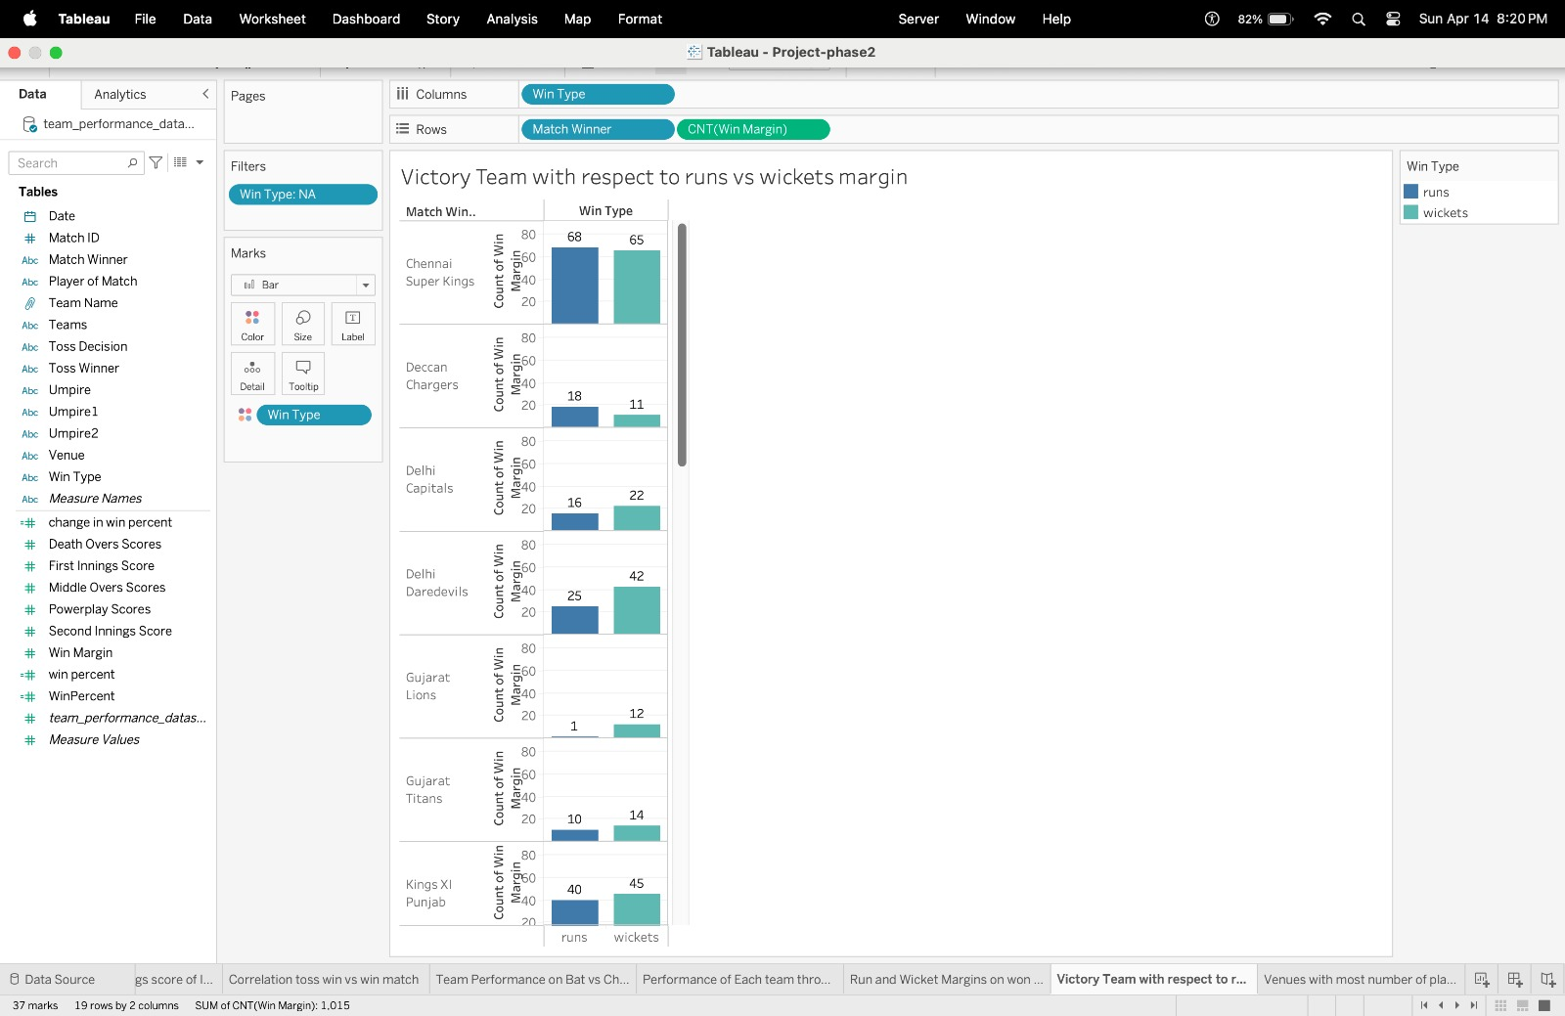

The visualization illustrates IPL team victory margins categorized into wins by runs and wins by wickets. Each bar symbolizes a team, with segments indicating wins by either scoring more runs or bowling out the opponent. The length of each segment reflects the number of wins by that margin, offering insights into team dominance and preferred victory methods—either through batting prowess or effective bowling. Pre-attentive attributes include length, color differentiation, vertical positioning, and alignment.



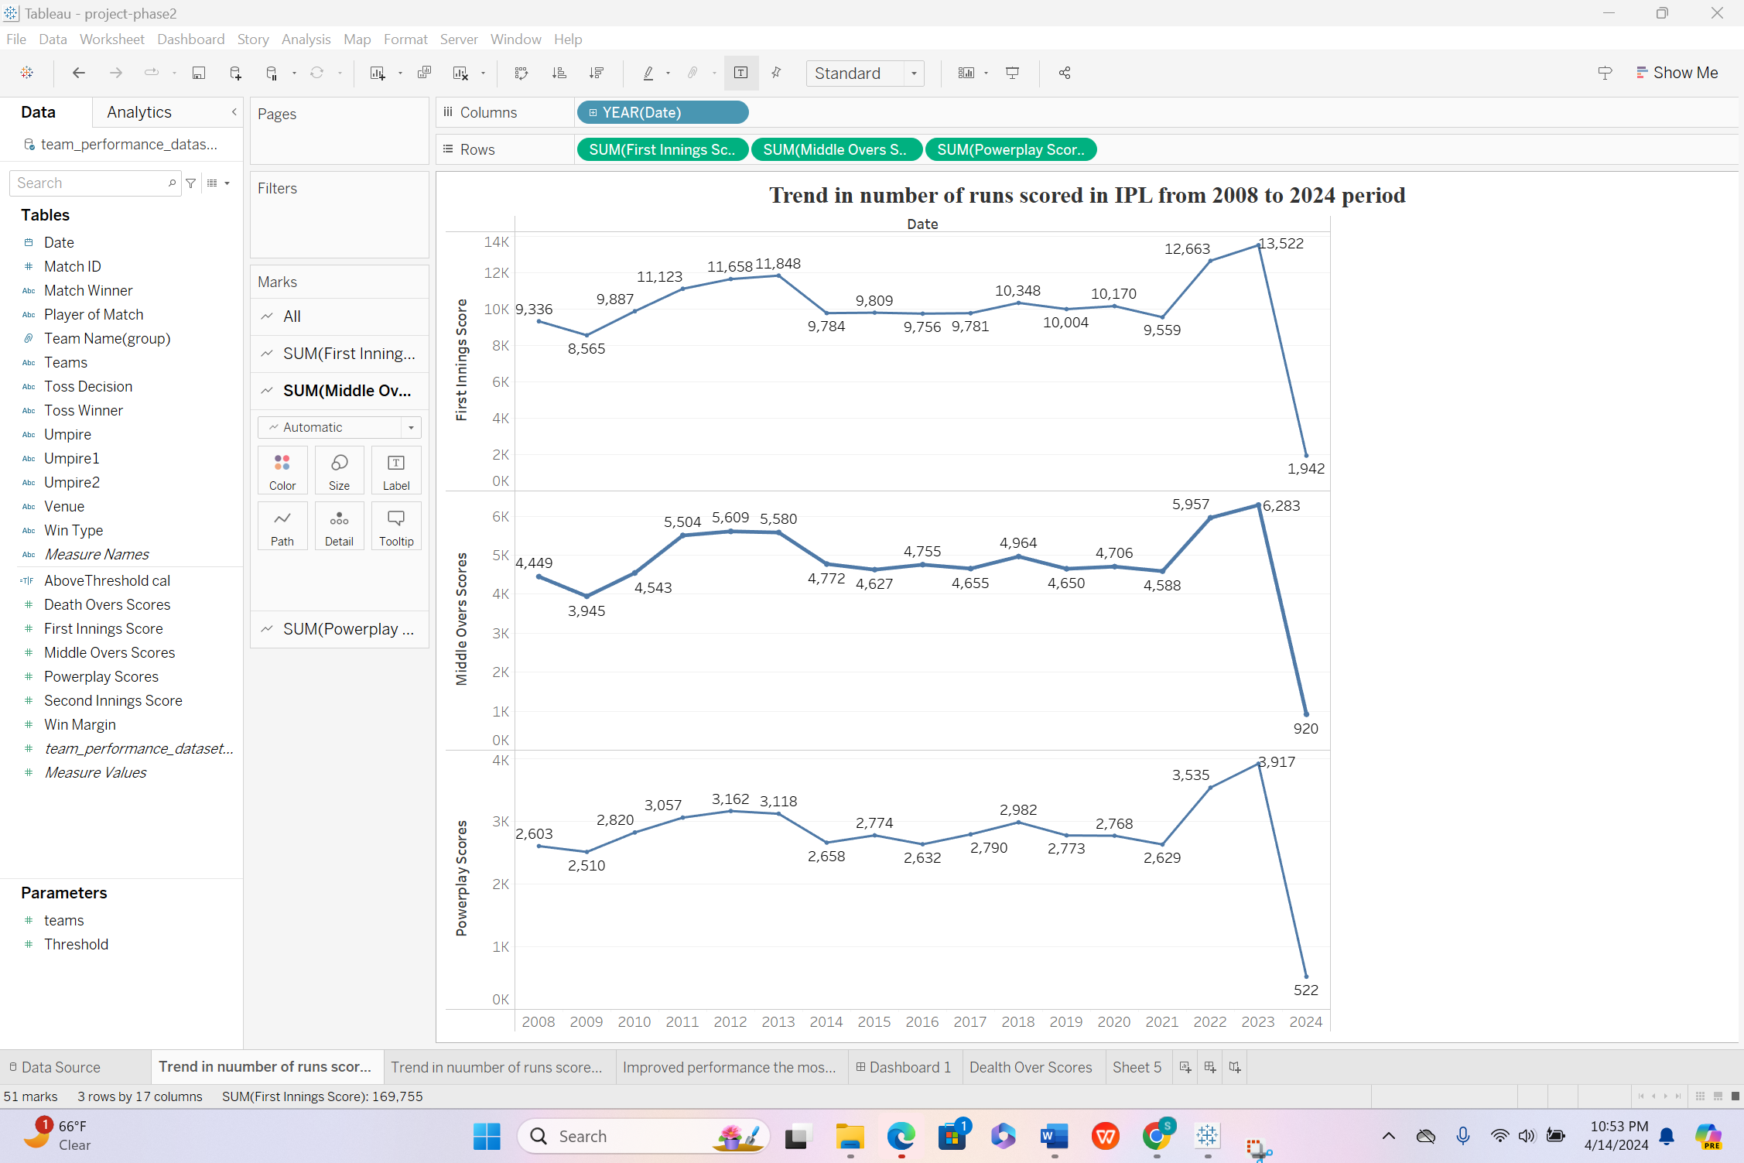

The line chart analyzes run-scoring patterns in IPL matches from 2008 to 2024 across three phases: Powerplay, Middle, and Death overs. Total runs scored are plotted on the y-axis against the years on the x-axis. Markers, possibly circles, indicate yearly totals. Observing line trajectories reveals run-scoring fluctuations, reflecting shifts in aggression or strategy. This aids in understanding scoring patterns and their historical evolution. Pre-attentive attributes include line color, shape, and positioning.

**Section VI: Dashboard Interactivity**

Calculated Fields, Parameters, and Filters in Tableau are crucial tools that add versatility and depth to data analysis and visualization. With Calculated Fields, users can craft custom expressions to generate new insights or alter existing data. Parameters offer dynamic interactions, enabling users to evaluate different scenarios and modify values without changing the base data. Filters improve the exploration of data by allowing users to selectively include or exclude certain data points, thereby enabling focused analysis and tailored visualizations.

**Question 8: Parameter creation: Threshold**

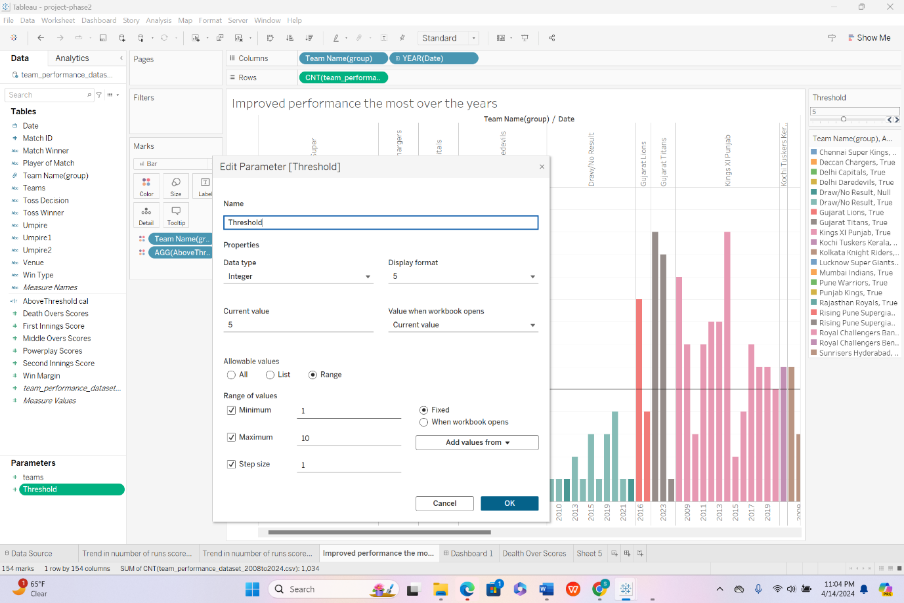

In Tableau, the "Threshold" parameter enables users to specify a number, typically associated with performance benchmarks or caps. Users can choose any value ranging from 1 to 10, and these choices are sourced directly from the dataset.

**Calculated fields: Above Threshold cal:**

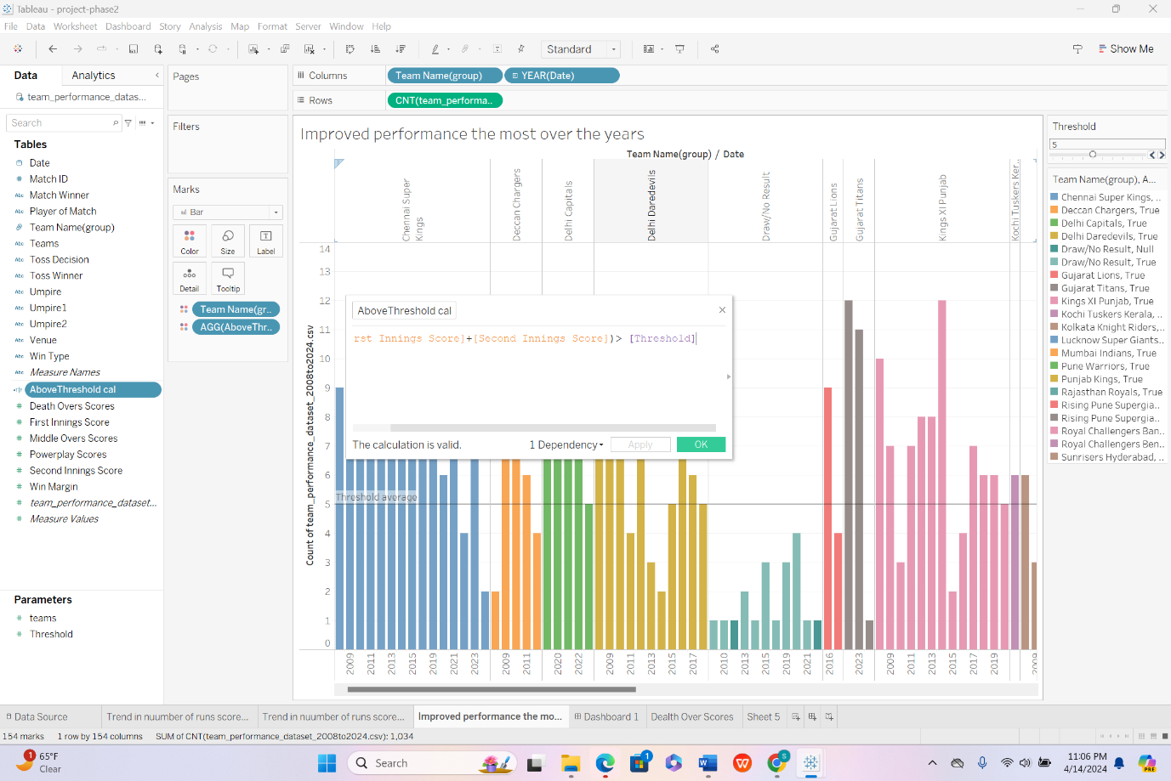

The "Above Threshold" function measures metrics against a predetermined threshold, potentially allowing users to choose among teams or groups. These choices are based on attributes found in the dataset.

**Question number 5: Parameter creation:**

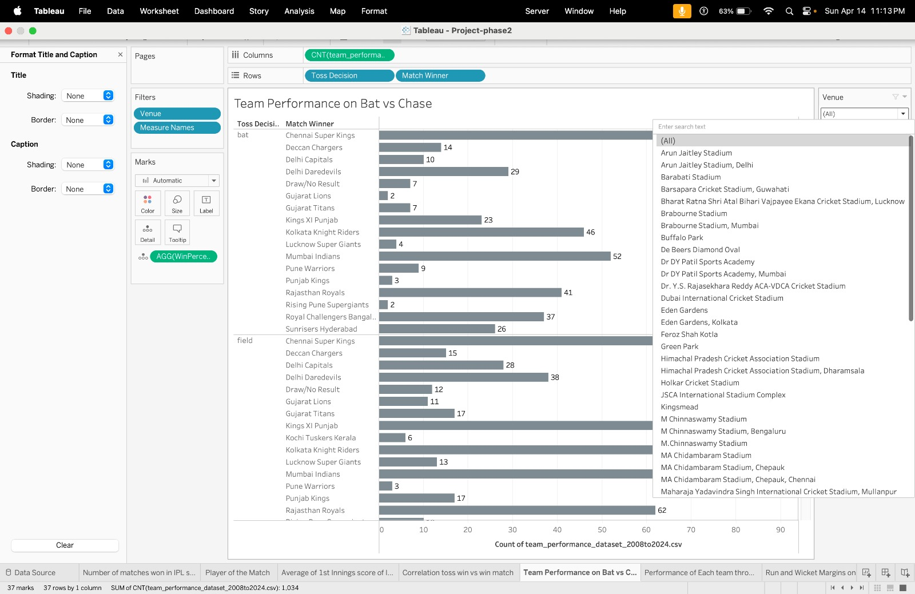

The dropdown menu for venues allows you to select from cricket stadiums or locations where matches are played.

**Question number 9: Interactive control lines**

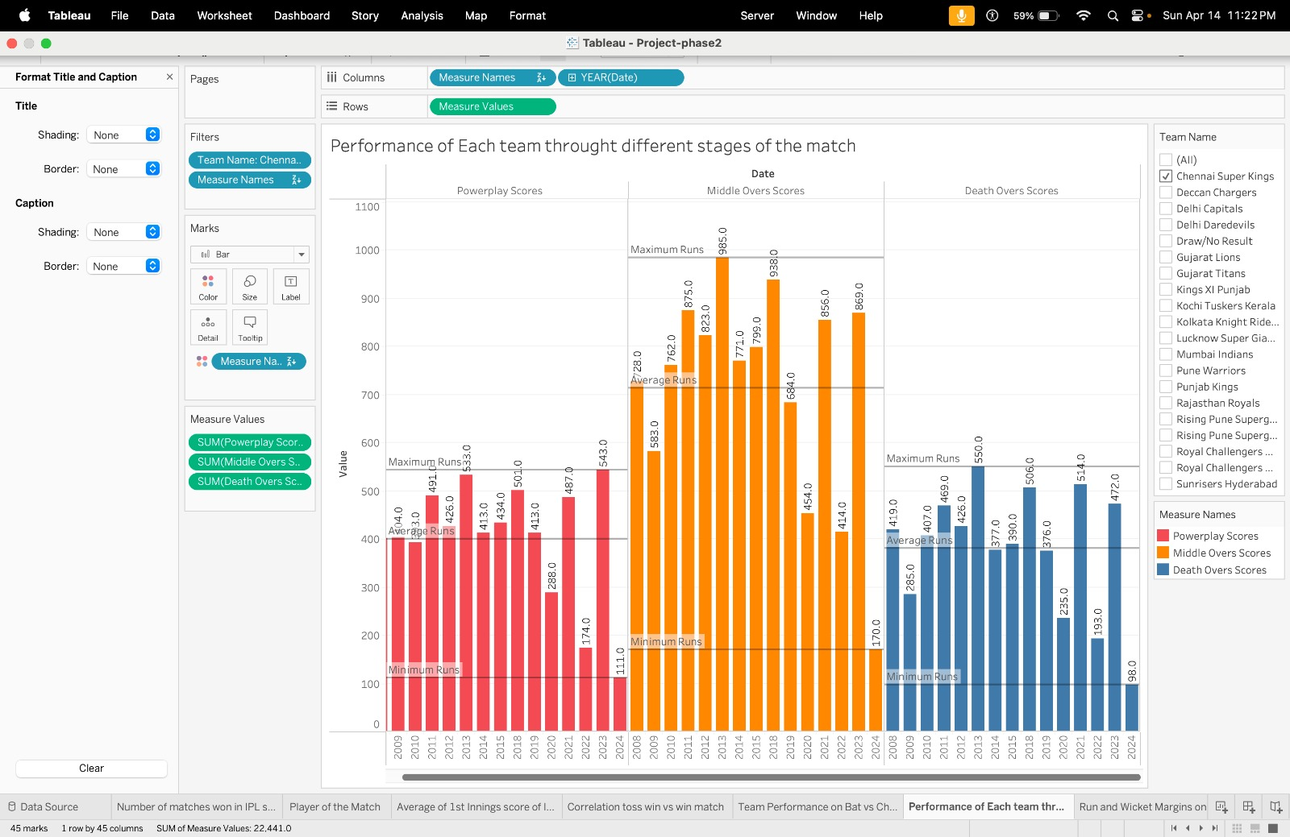

The "Team Name" checkboxes enable the selection of cricket teams, probably from a data field containing team details. The "Measure Names" checkboxes allow for the choice of performance indicators such as Powerplay Scores, Middle Overs Scores, and Death Overs Scores, likely sourced from a data field listing these metric names.

**Tableau Public:**

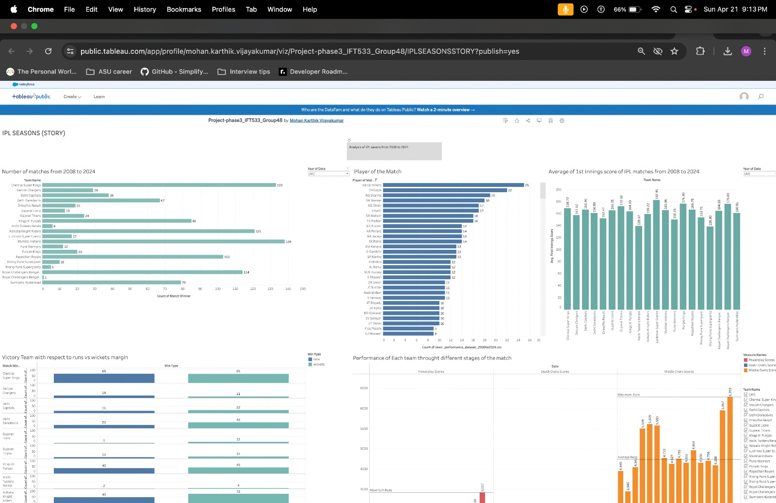

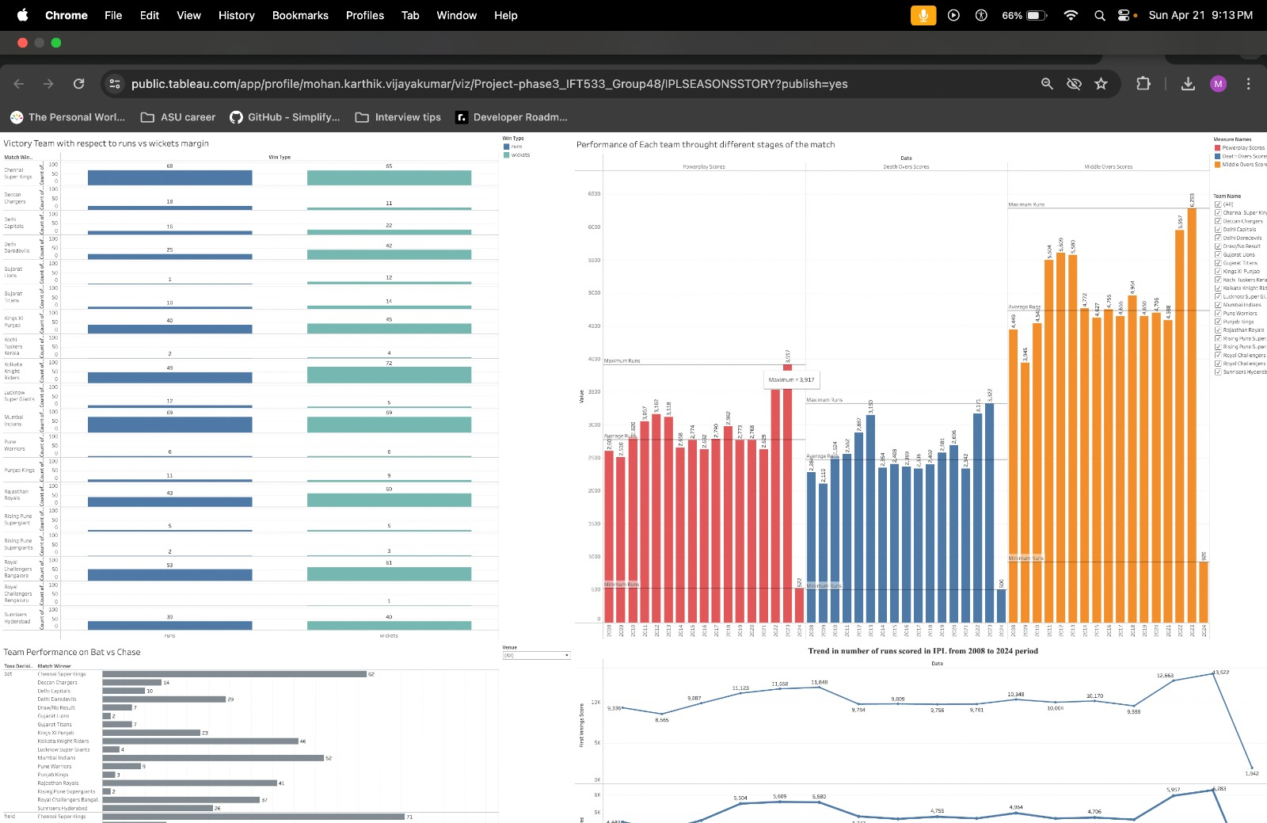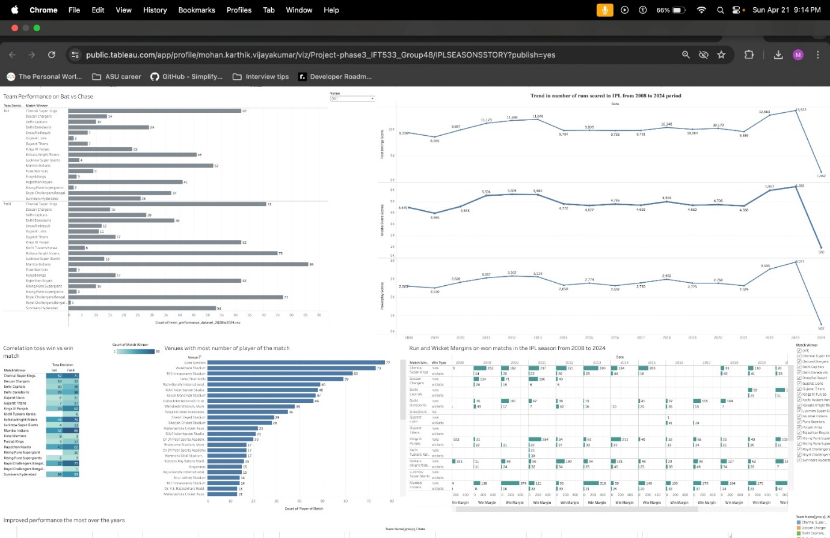

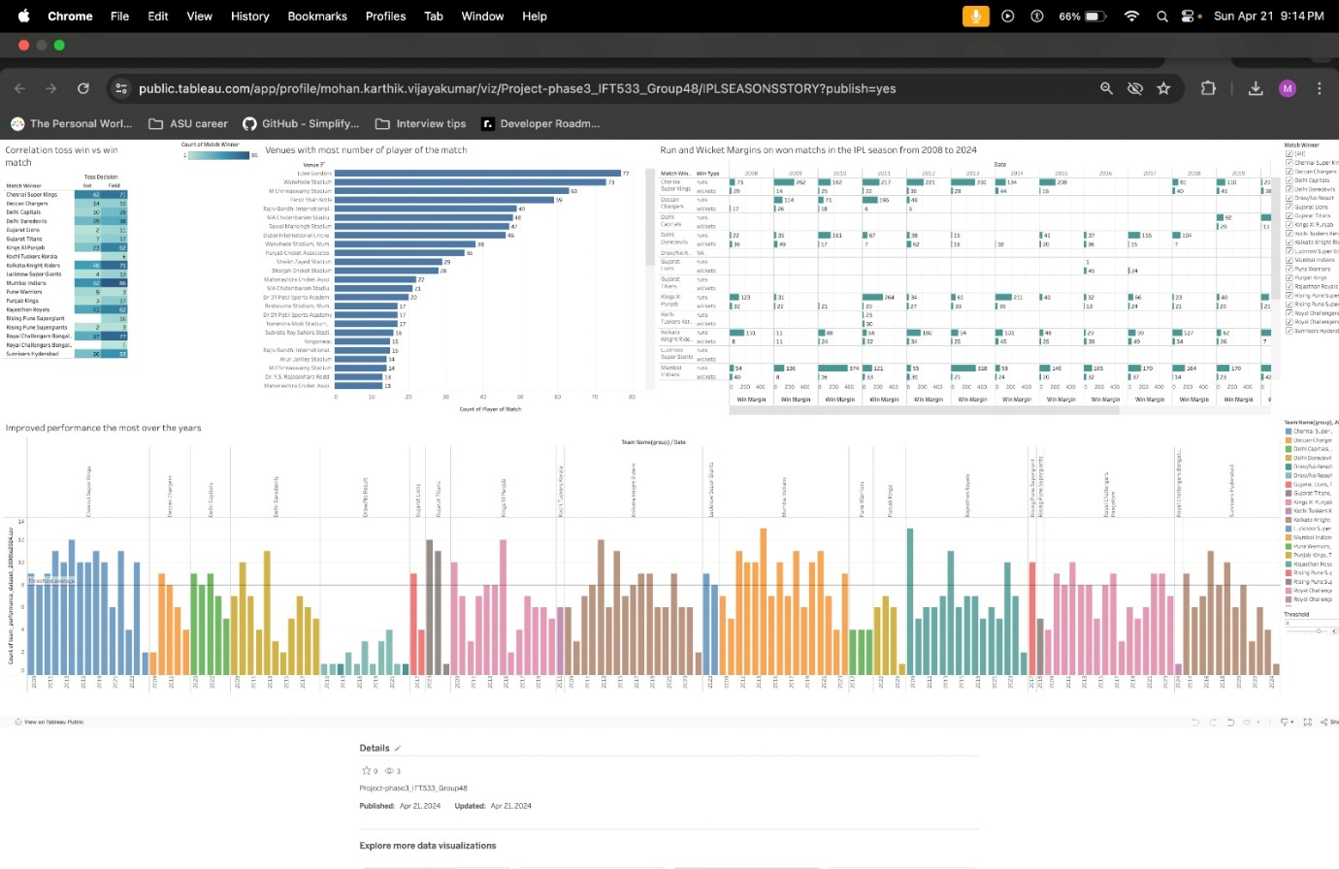

**Extra Credit:**

**We have created the Story, Calculated fields, Parameter fields user interactivity controls.**

**Story:**

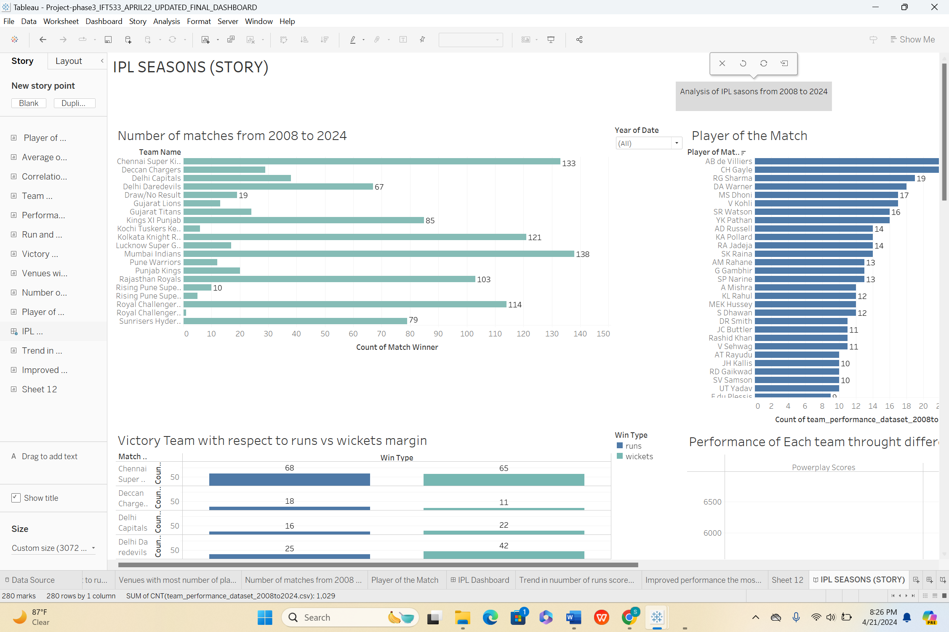

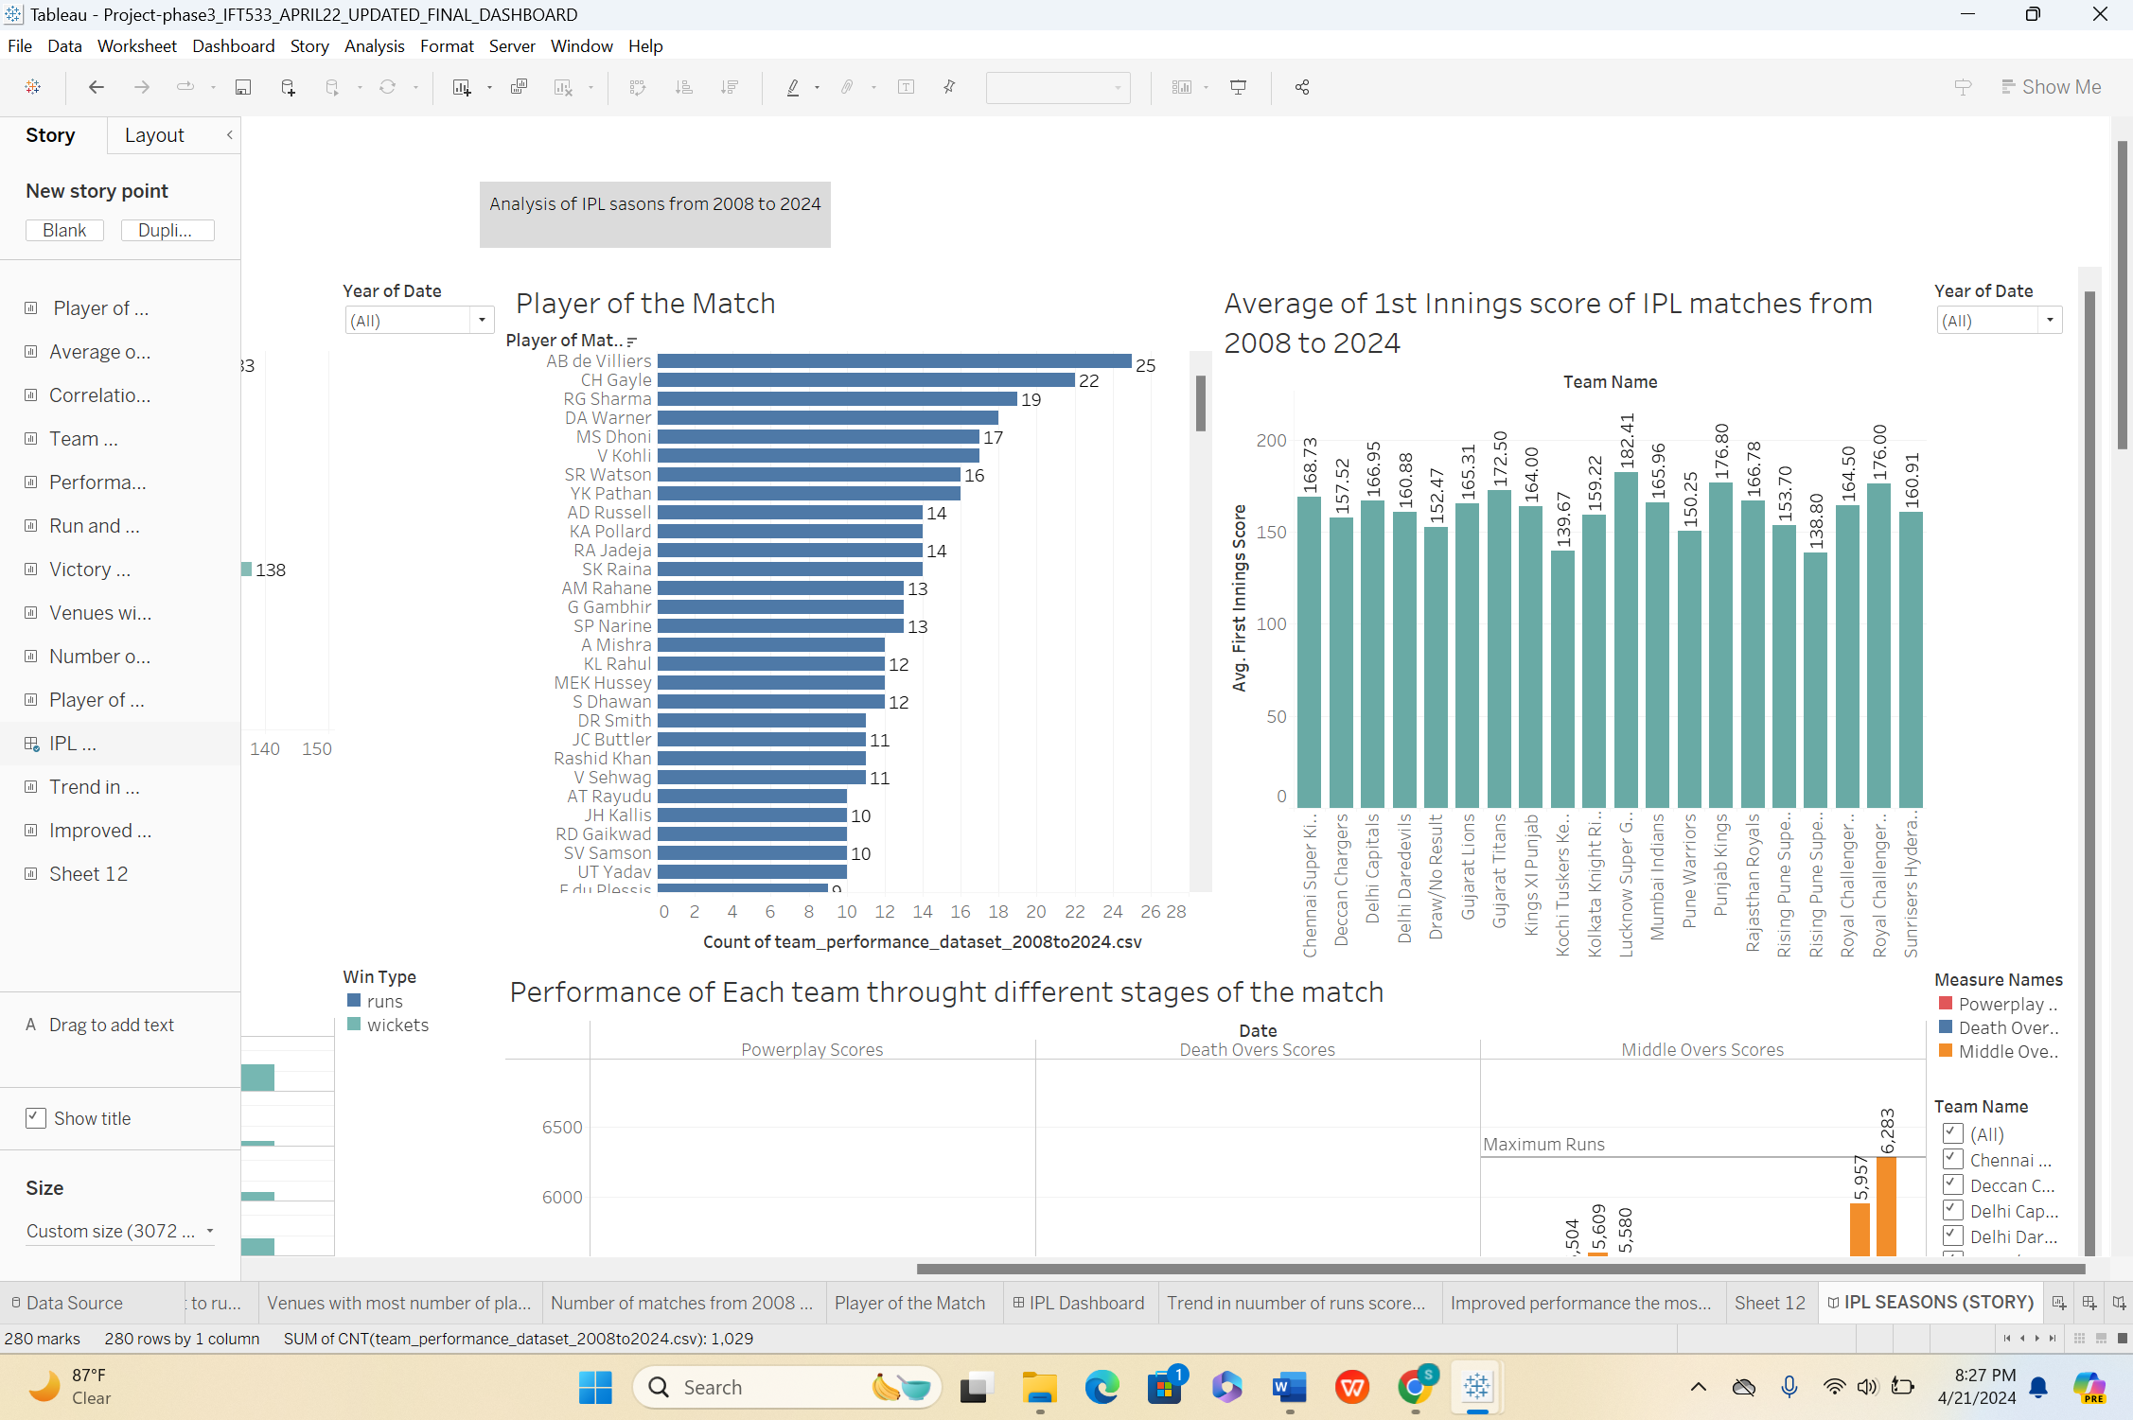

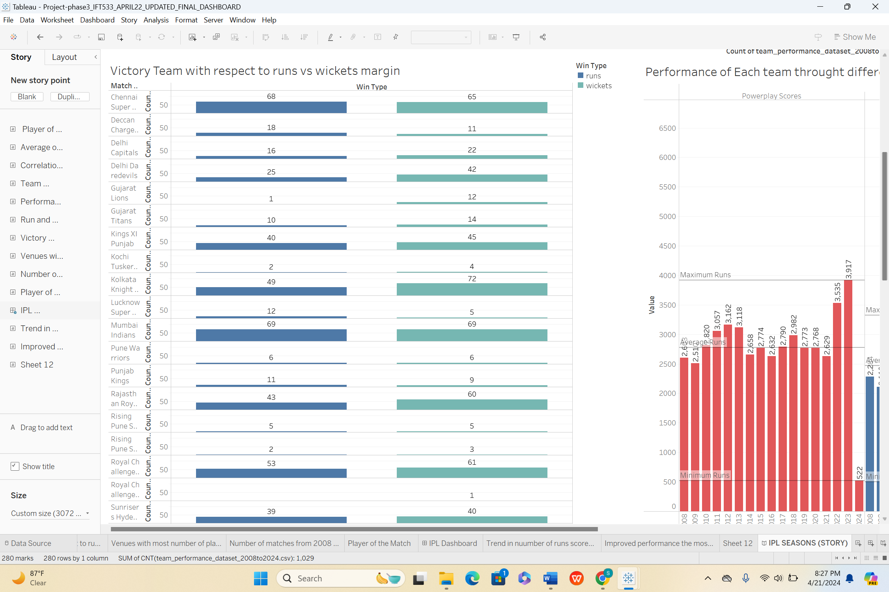

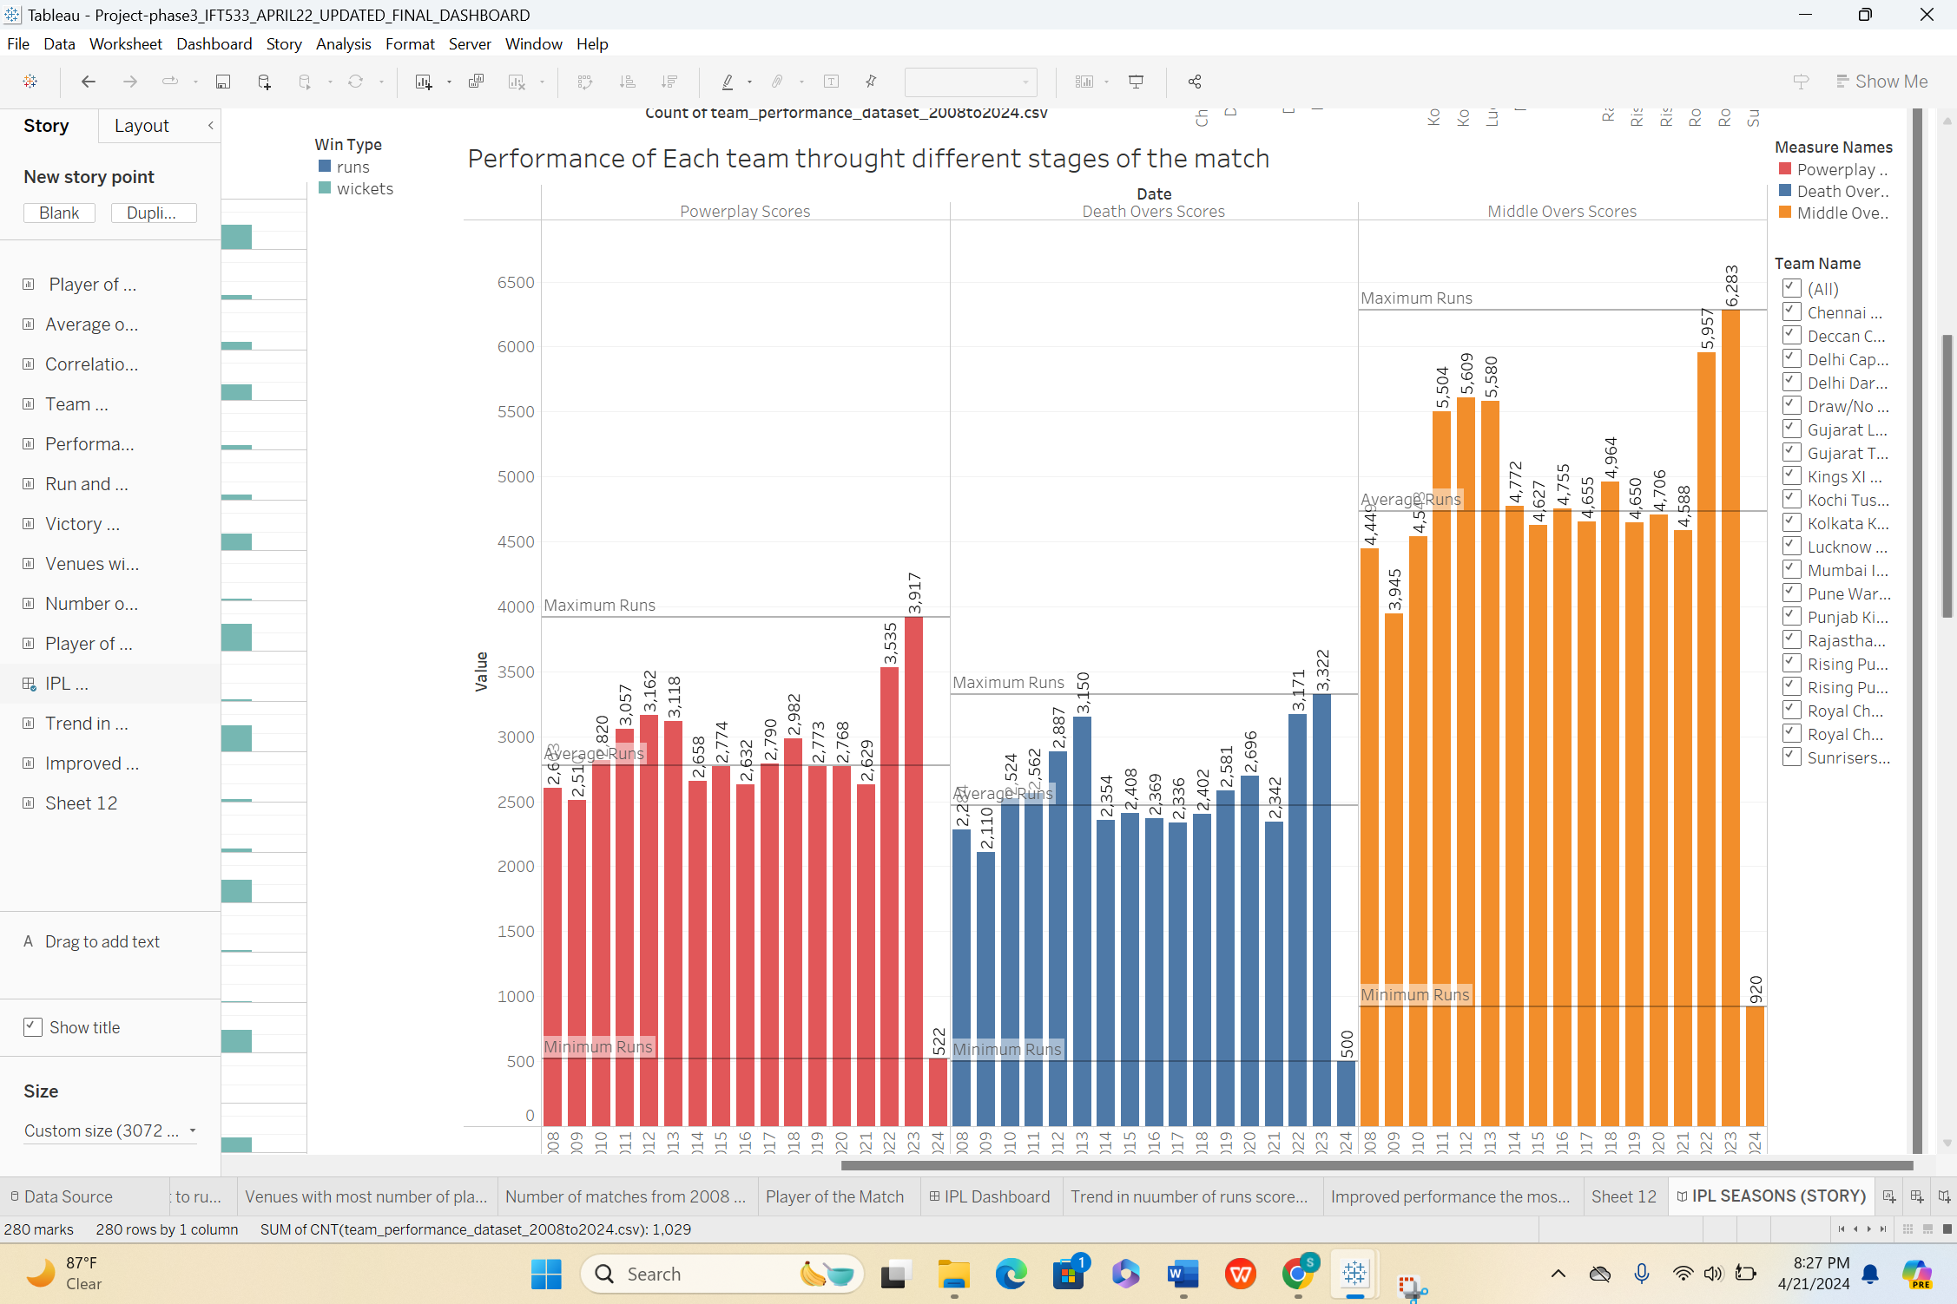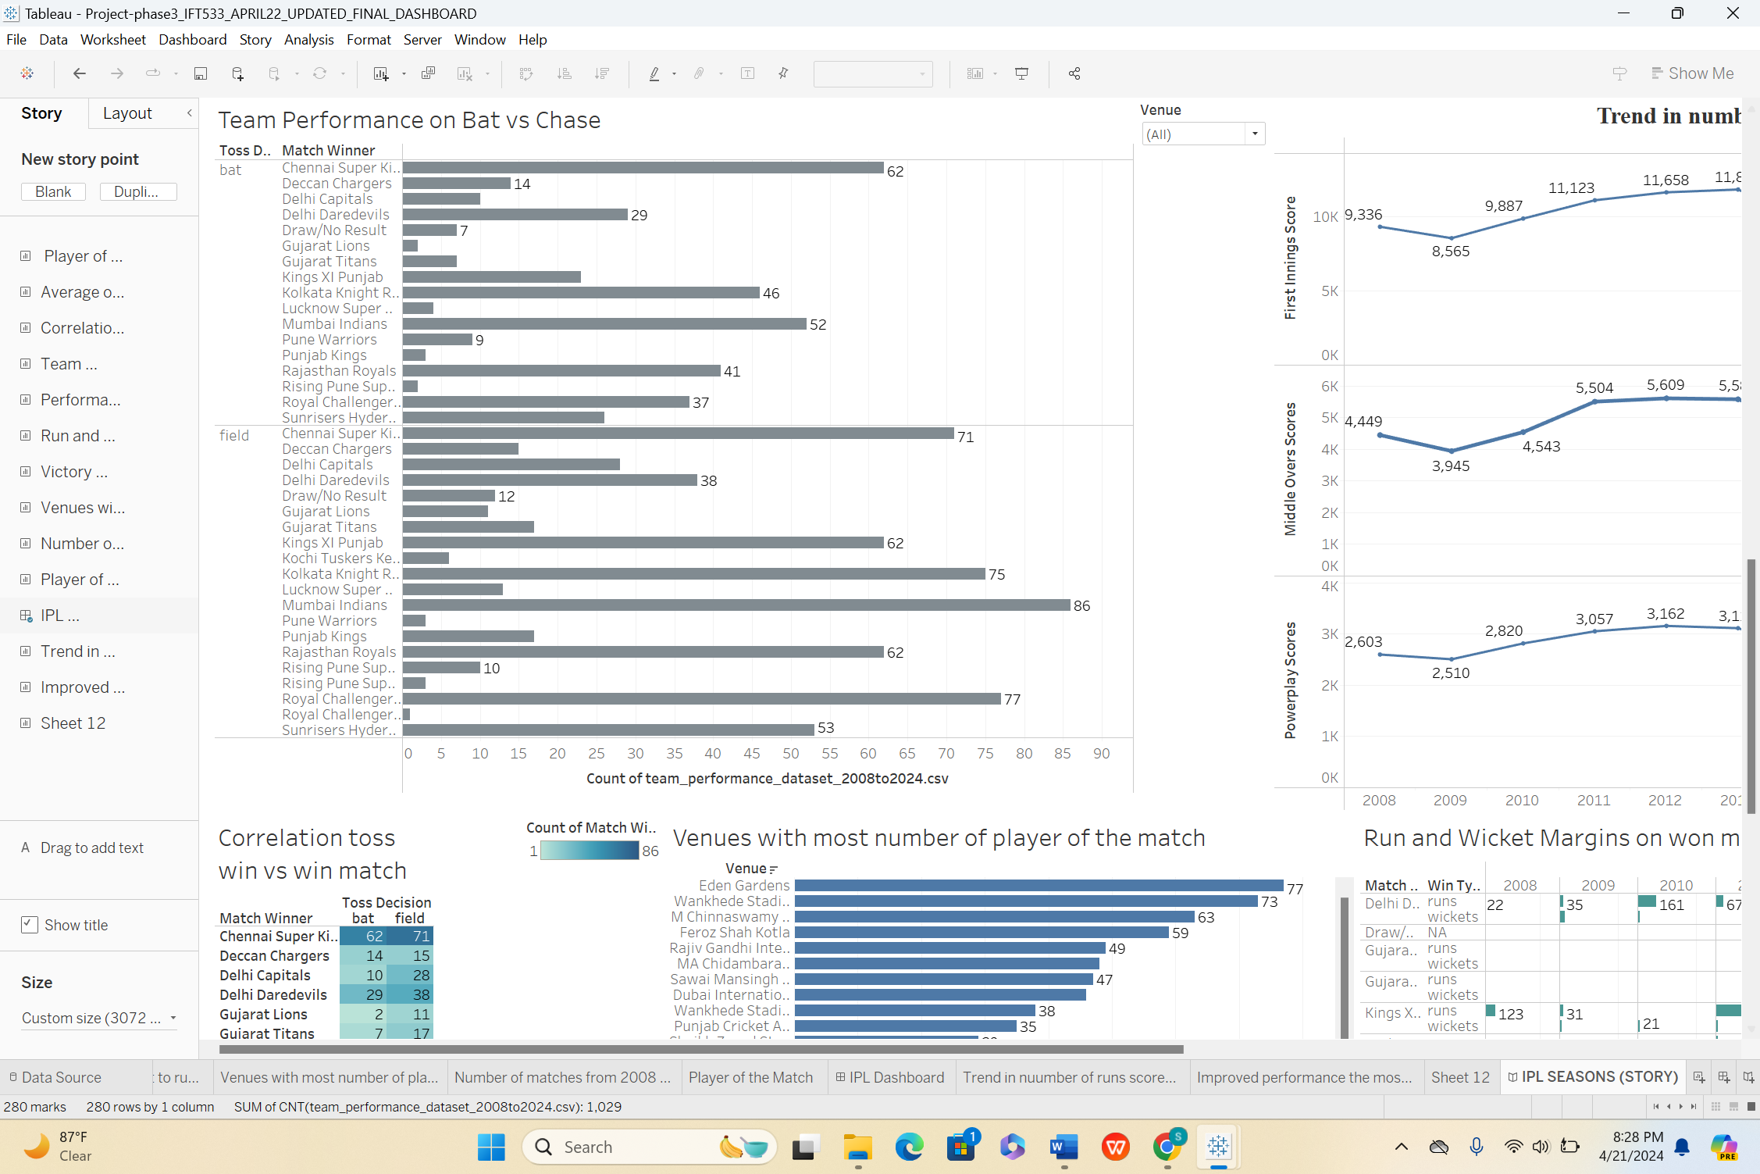

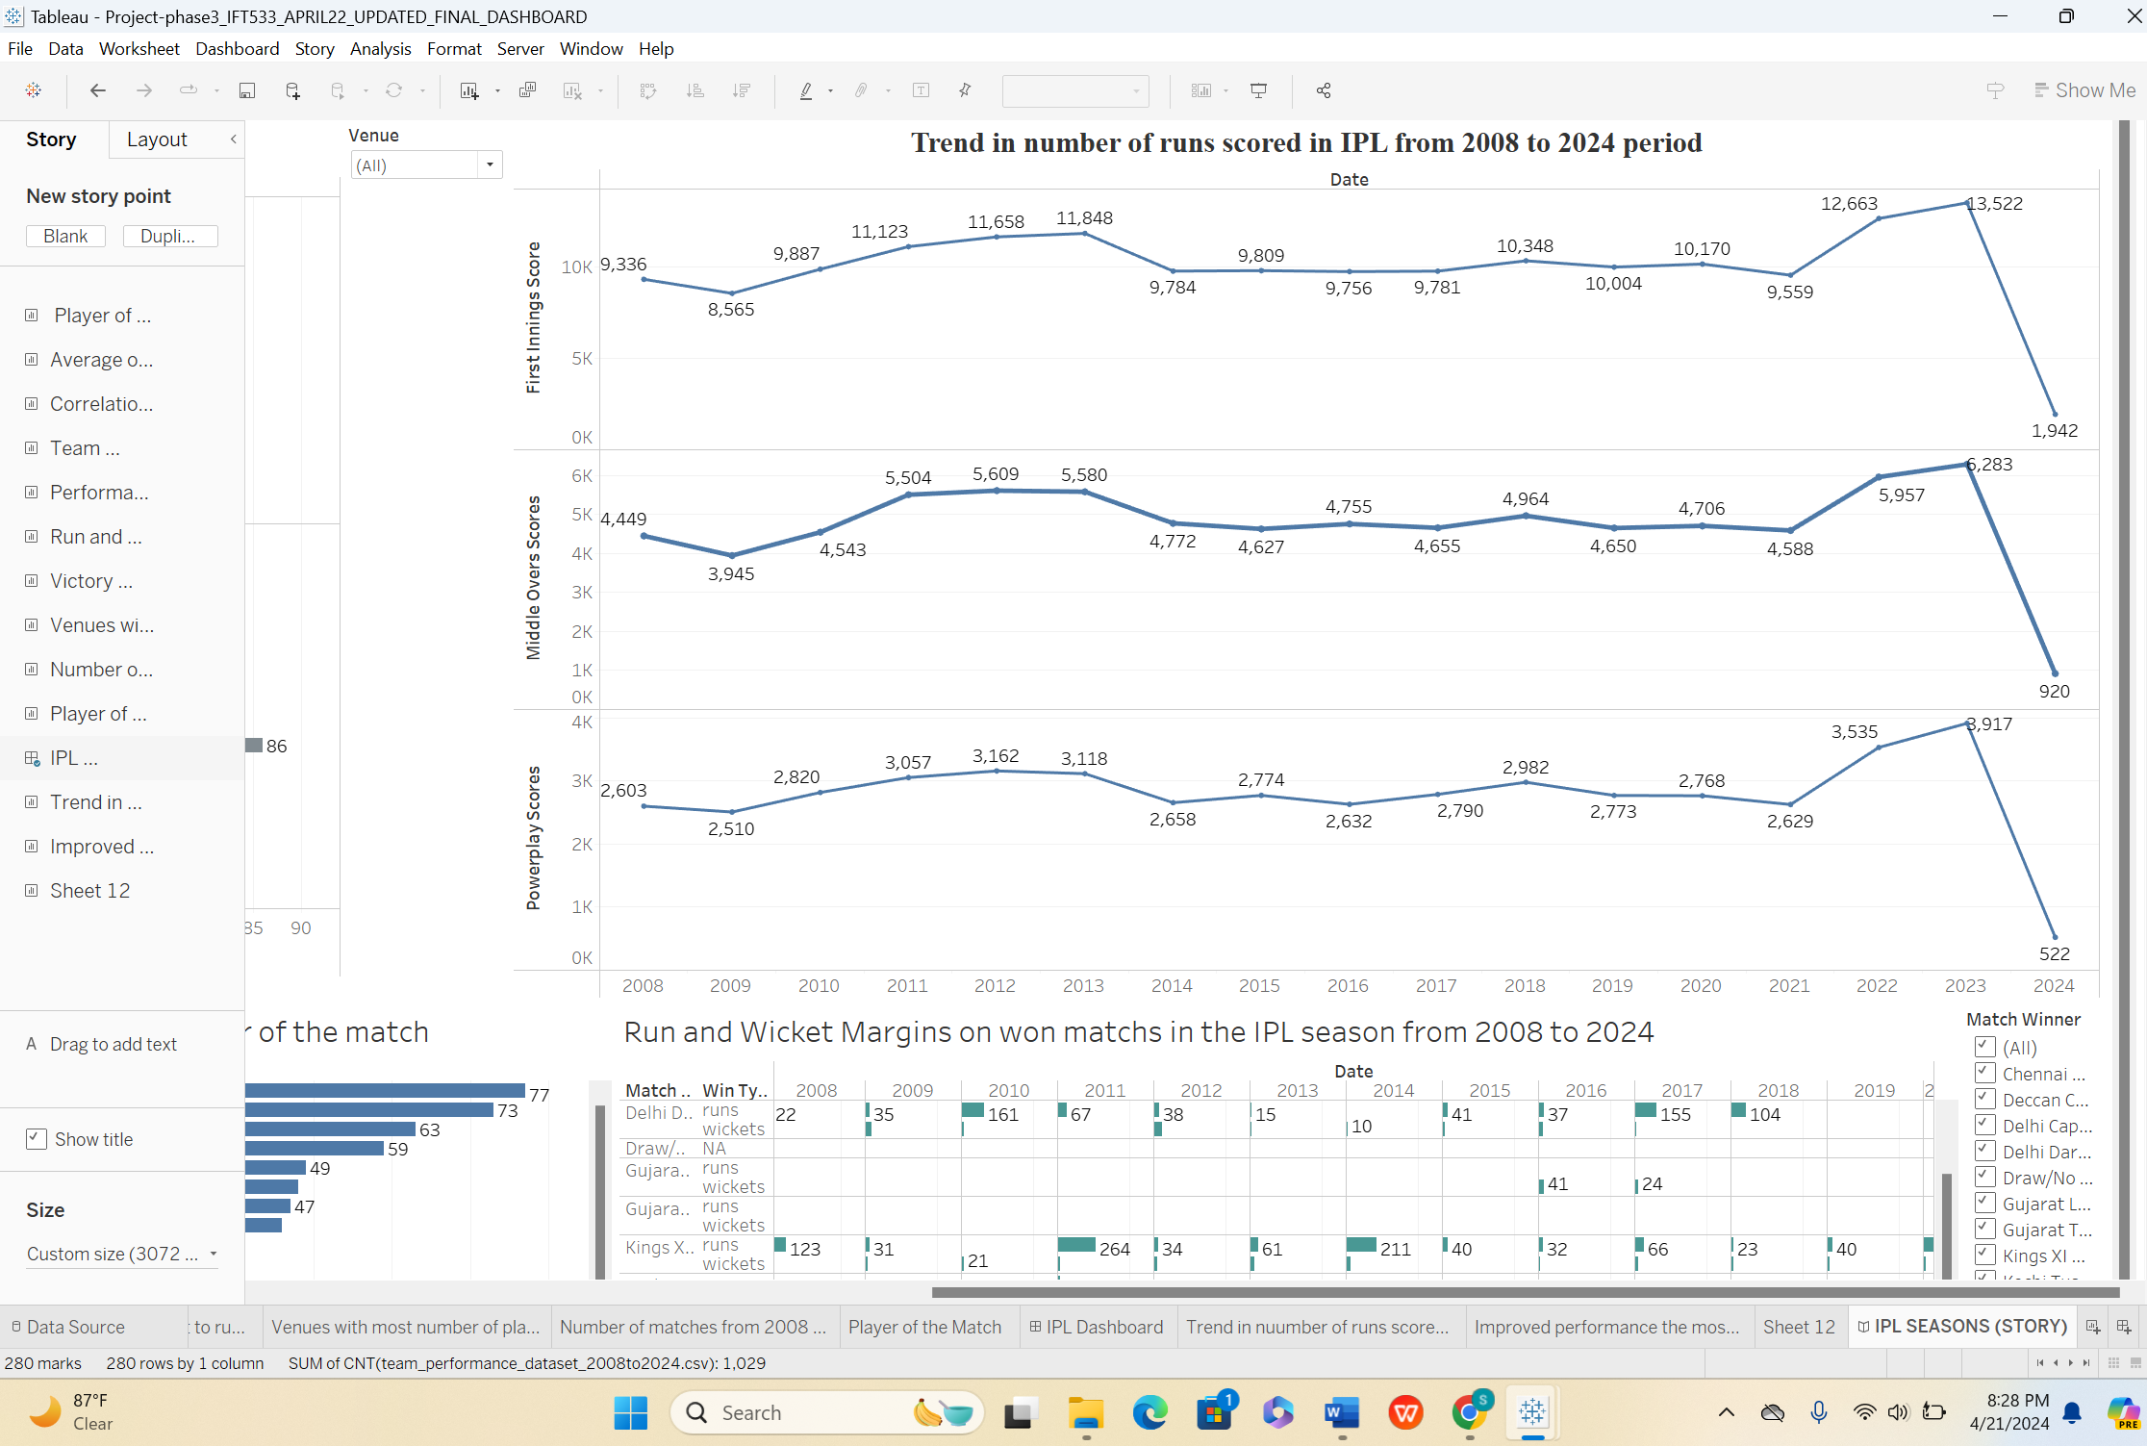

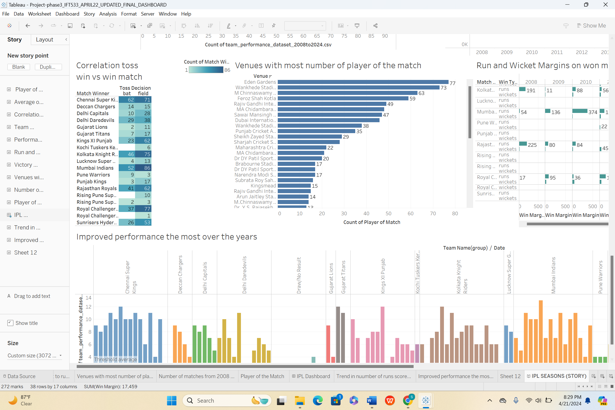

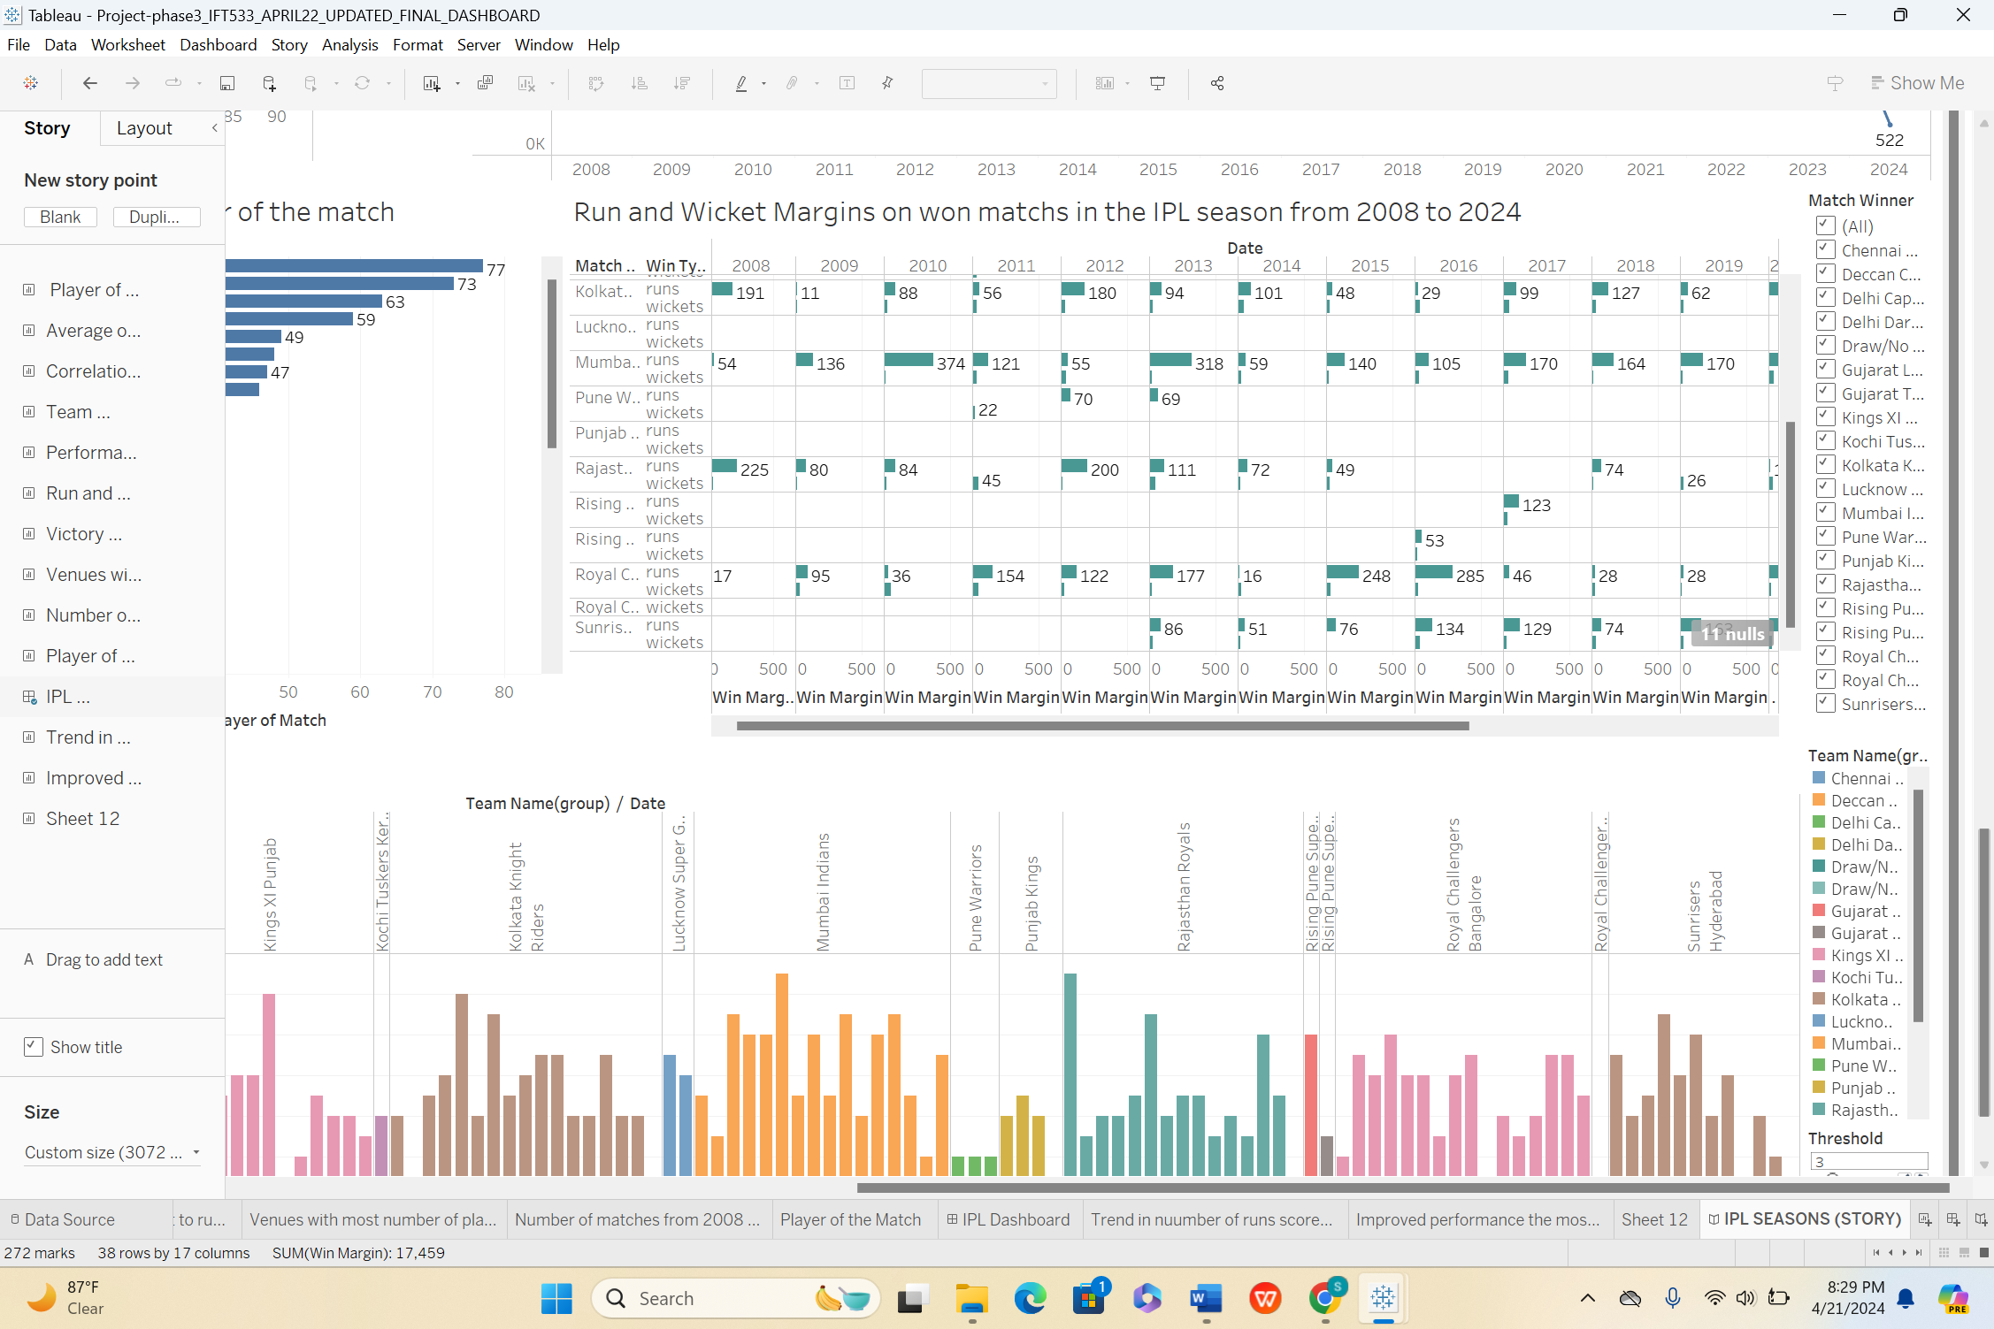

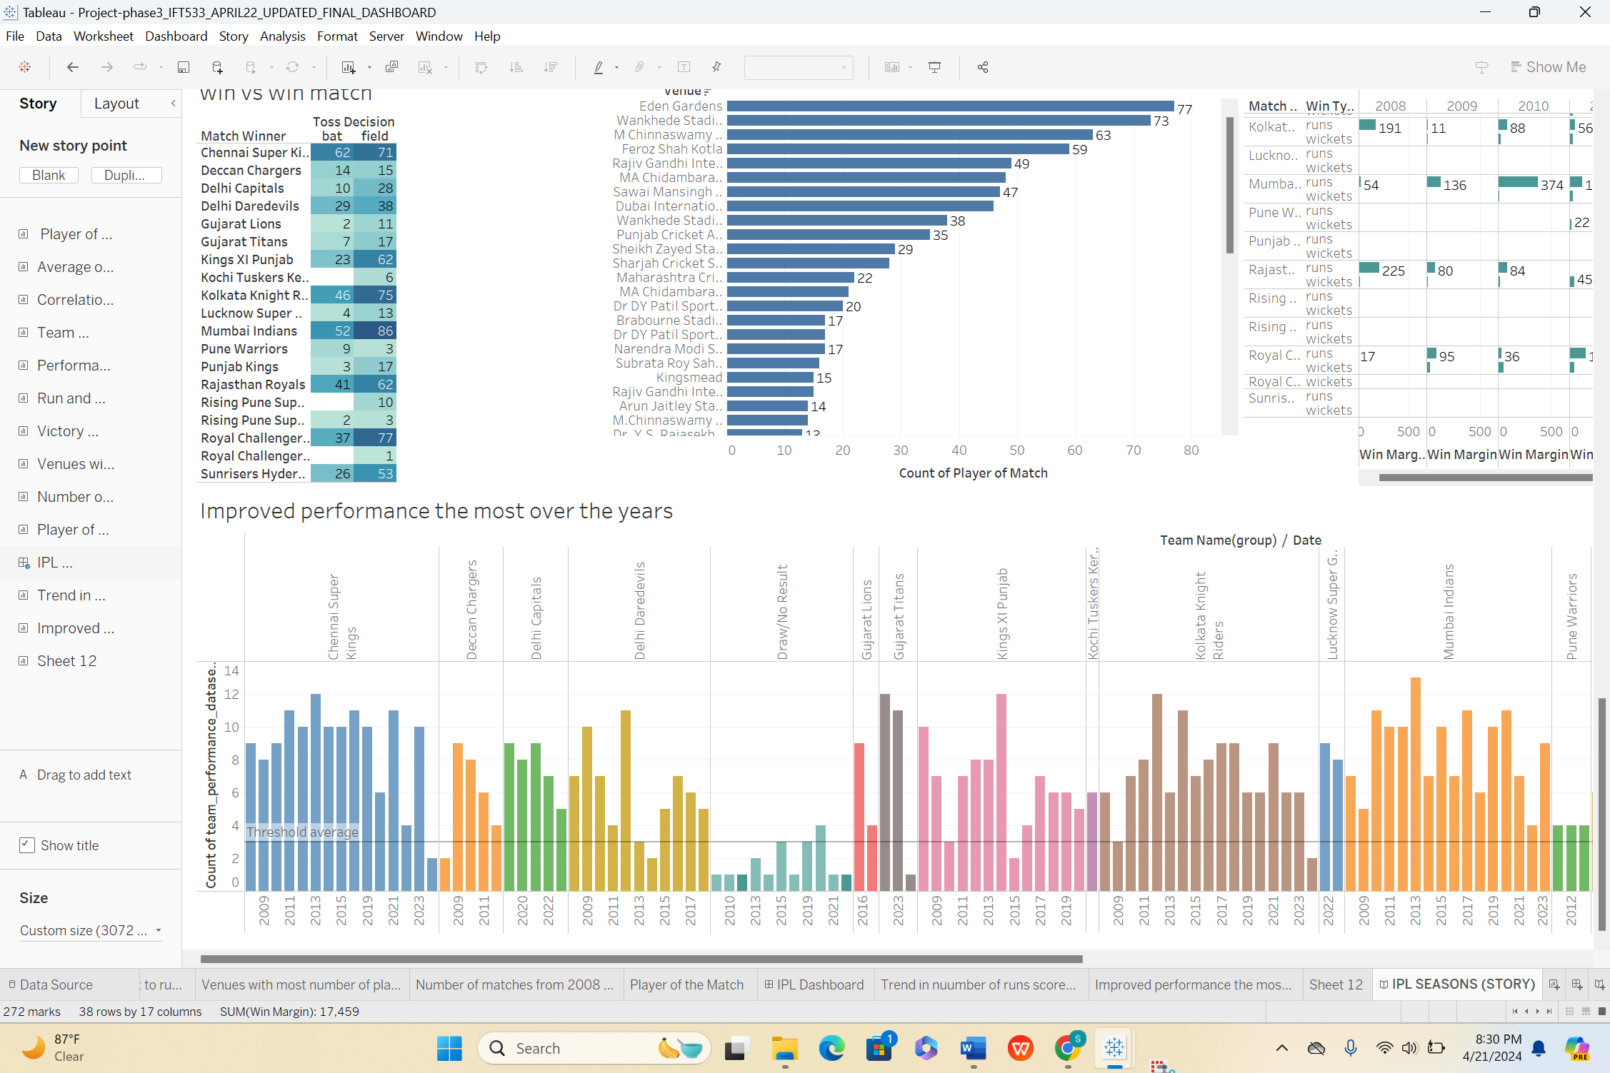

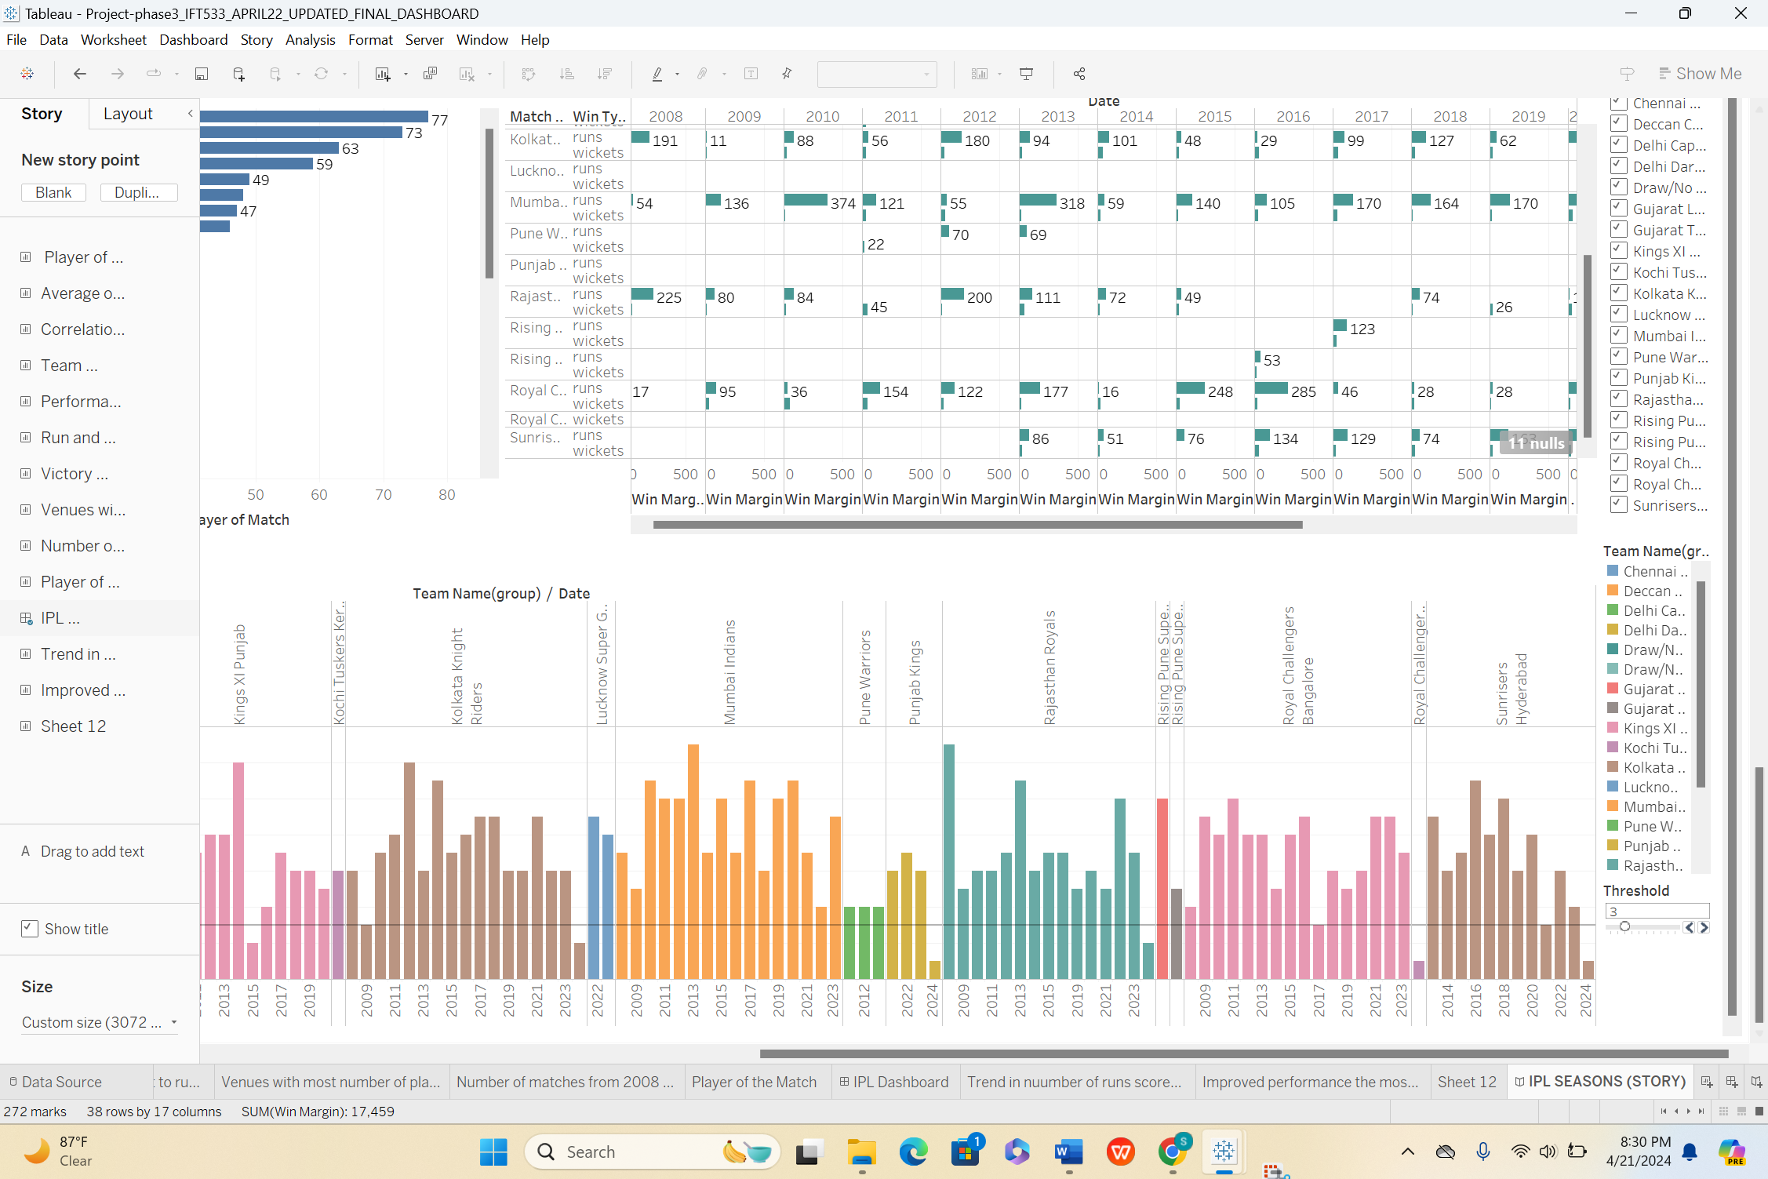

**Creation of Interactivity controls:**

**For threshold value 7**

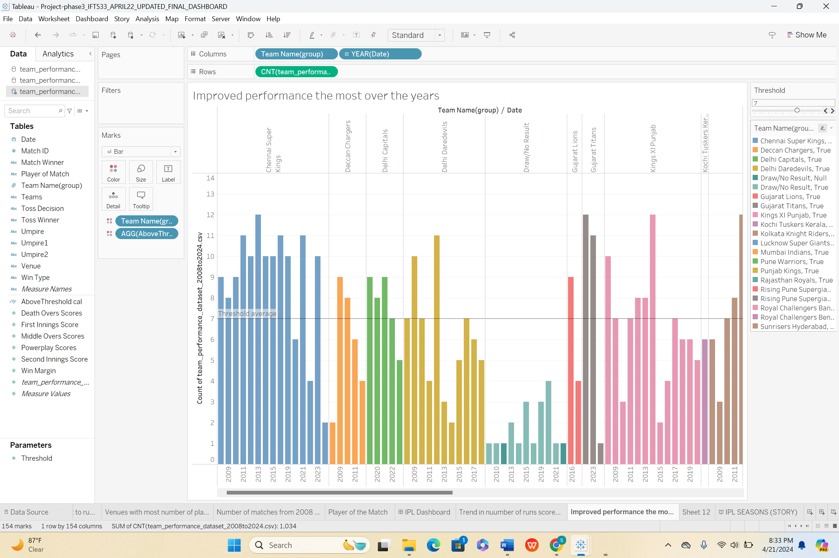

**For threshold value 4:**

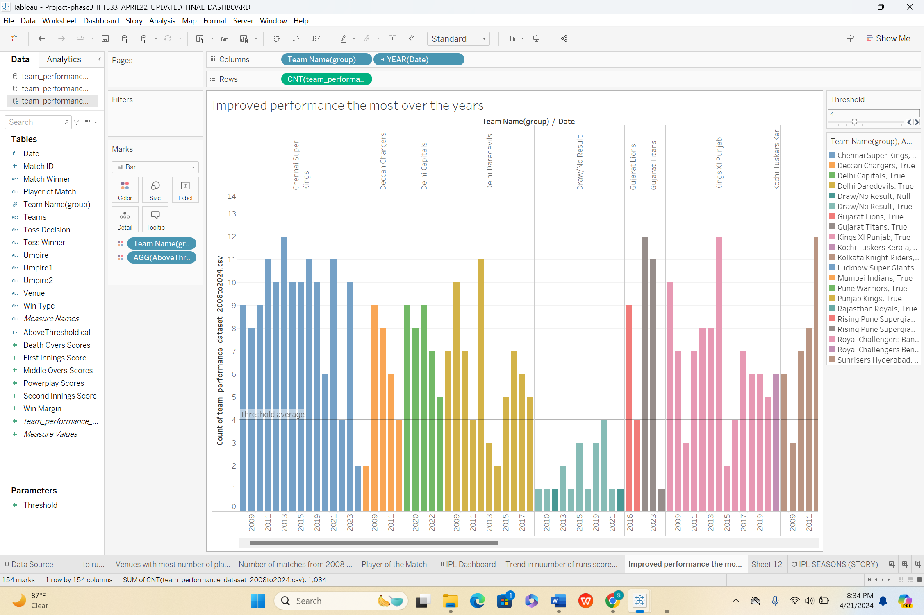

**References**

**Reference**

**Mural**

<https://app.mural.co/t/sparkysdv8610/m/sparkysdv8610/1712091668834/567dc646adf7d16496ed1fc7bea813184e6551ce?sender=u603637f2b15fb9aa7fa14990>

**Dataset Source**

<https://www.kaggle.com/datasets/saiprudvirajy/indian-premier-league-ipl-2008-2024/data>

**Tableau Public :**

[**https://public.tableau.com/app/profile/mohan.karthik.vijayakumar/viz/Project-phase3_IFT533_Group48/IPLSEASONSSTORY?publish=yes**](https://public.tableau.com/app/profile/mohan.karthik.vijayakumar/viz/Project-phase3_IFT533_Group48/IPLSEASONSSTORY?publish=yes)